Jamie Lionel Meggs

July 15, 1977 – November 19, 2019

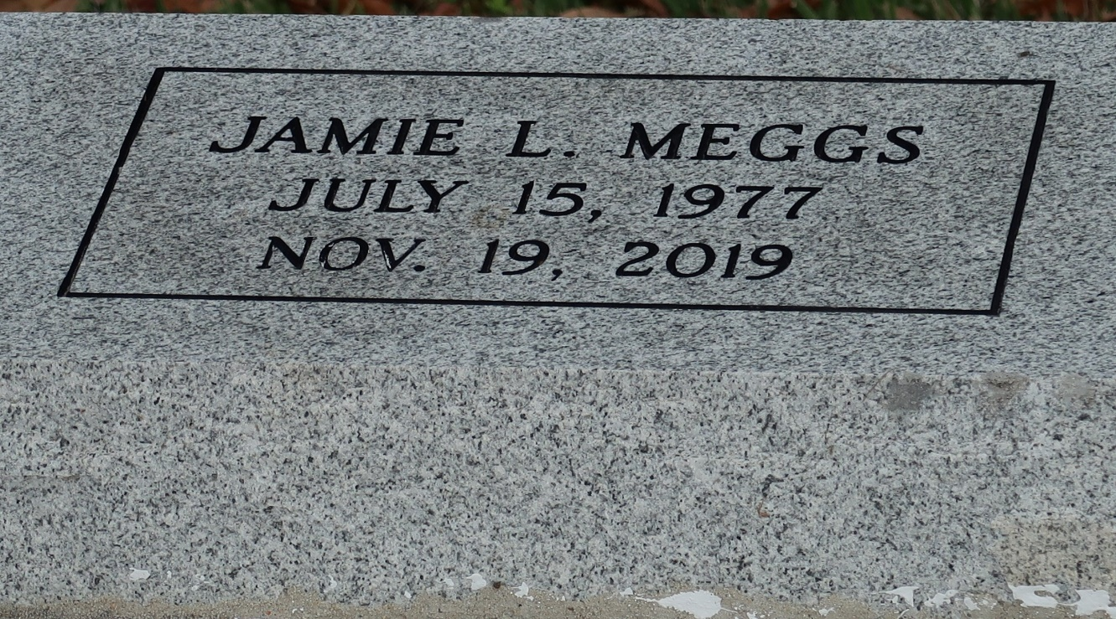

A native of St. James. He passed away at 5:39 p.m. on Tuesday, November 19, 2019 at Our Lady of the Lake Regional Medical Center, Baton Rouge. He was 42.

Visiting at Greater Golden Grove Baptist Church, Gramercy, Saturday, November 30, 2019 from 9:00 a.m. until Religious Services at 10:00 a.m. conducted by Rev. Ulysses Jarrow, Jr. Interment in St. James Catholic Church Cemetery, St. James.

Survived by his father Osborne Kelson and mother Kathy Kelson, four daughter: Keandra Meggs, Ja'Miya Bowers, Ja'Myri Meggs and Ja'Niya Meggs and son Da'Quan Bowers. Six brothers: Rene Kelson, Kyron Kelson, Sr., Kurt Kelson, Sr. Osborne Kelson, Jr. Anthony Kelson and Desmond Kelson, aunts, uncles, nieces, nephew, couisins, other relatives and friends.

Preceded in death by his grandparents Sidney Meggs, Sr. and Dorothy Mae Well Meggs, uncles: Spencer Meggs and Sidney Meggs, Jr. and aunt Brenda Meggs.

BRAZIER-WATSON FUNERAL HOME IN CHARGE OF ARRANGEMENTS.

Brazier-Watson Funeral Home, Donaldsonville, LA