Sidney Meggs, Sr.

September 30, 1920 – December 15, 2001

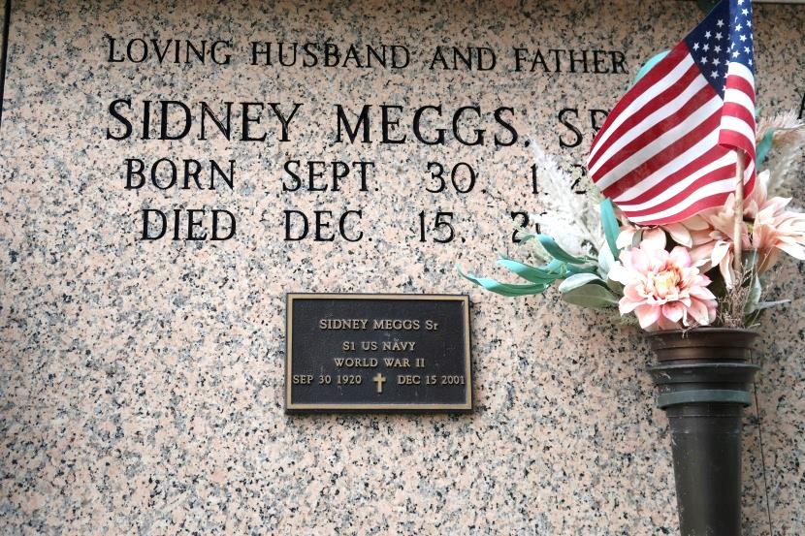

**Sidney Meggs Sr., 81**

A native and resident of St. James, he died at 3:45 p.m. Saturday, Dec. 15, 2001, at Thibodaux Regional Medical Center, Thibodaux. He was 81. Visiting at Mount Calvary Baptist Church, St. James, from 9:30 a.m. Wednesday until religious services at 11 a.m., with the Rev. Samuel Jones officiating. Entombment in St. James Catholic Church Mausoleum, St. James.

Survived by his wife, Dorothy Wells Meggs, St. James; two daughters, Carolyn Meggs, St. James, and Kathy Meggs Kelson, Gramercy; a son, Sidney Meggs Jr., New Orleans; two sisters, Geneva Shephard and Nellie Mae Ceasar; 10 grandchildren, seven great-grandchildren; a daughter-in-law, Sybil Meggs; a son-in-law, Osborne Kelson; and nieces, nephews, cousins, other relatives and friends.

Preceded in death by his parents, Nathan Meggs and Florence Ellis Meggs; a daughter, Brenda Meggs; a son, Spencer Meggs; four brothers, Warren, Walter, Amite and Nathan Meggs Jr.; and a sister, Florence Rodney. Brazier-Watson Funeral Home, Donaldsonville, in charge of arrangements.

Advocate, The (Baton Rouge, LA)

Tuesday, December 18, 2001