Glenn M. Melancon Sr.

April 23, 1955 – March 8, 2012

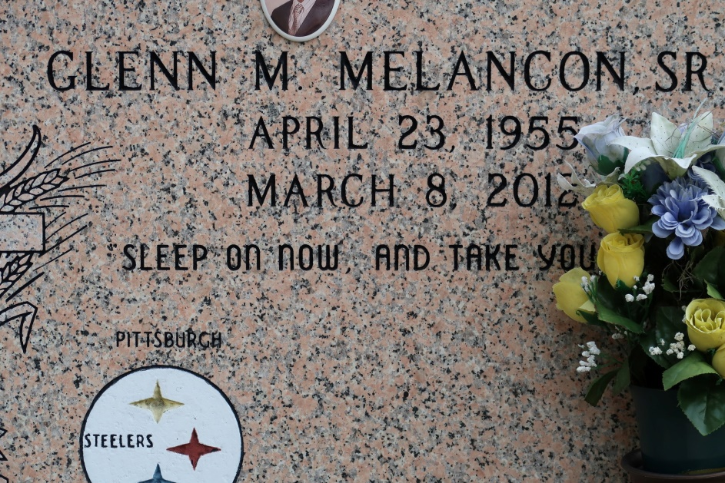

Glenn "Skeet" Melancon, Sr. departed this life on Thursday, March 8, 2012.

Son of the late Flavia Nash Melancon and Joseph Melancon, Sr. Devoted husband of Shelia Pierre Melancon. Father of Shona, Glenn, Jr., and Grent Melancon. Grandfather of Tyler Lumar and Ky'Ren Melancon. Brother of Florence Roussell, Stella (Curtis) Castle, Royal, Steve (Debra), Raymond, Larry (Linda), Roland (Josephine), Clinton (Rita), Barry (Verlyn). Son-in-law of Fabiola Pierre. Brother-in-law of Rev. Douglas (Wanda), Michael, Bernard, Jerome, Richard (Wanda) Pierre, Joyce (Edmond) Morton, Marion (Lionel) Williams, Marilyn Pierre and Kathleen Hebert (Clarence). Also survived by a host of nieces, nephews, cousins, relatives and friends.

Relatives, friends, surrounding churches and employees of Motiva Enterprises of Convent, Louisiana are invited to attend Funeral Services at St. James Catholic Church, 6613 Louisiana 18, St. James, Louisiana on Friday, March 16, 2012 at 10:00 a.m. Officiated by Father Christopher Decker. Visitation is from 8:00 a.m. until time of service. Interment will be at St. James Catholic Church Cemetery. Repast to follow at the Westbank Reception Hall. Funeral Services entrusted at The Baloney Funeral Home, LLC., 399 Earl Baloney Street, Garyville, Louisiana, (985) 535-2540.

The Times-Picayune, New Orleans, Louisiana

March 13 - 15, 2012