Shelia Ann (Pierre) Melancon
December 1, 1953 – November 14, 2022

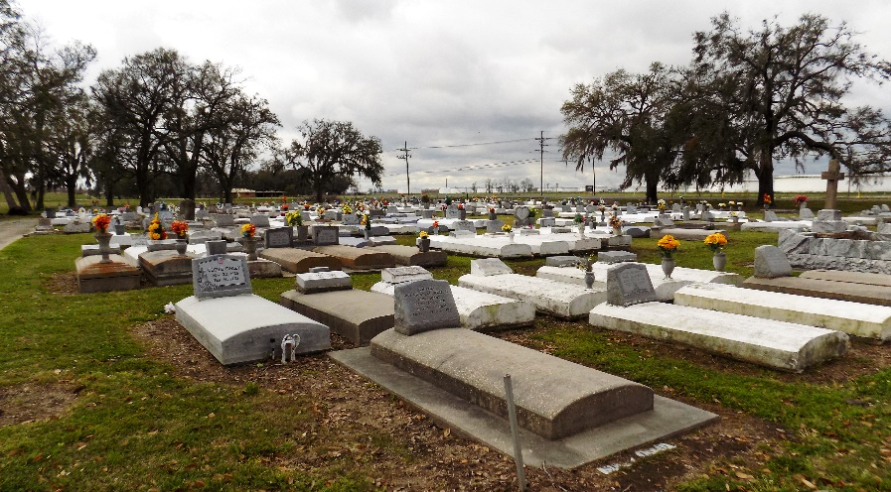
Shelia Ann Pierre Melancon was born on December 1,1953 to Elex Pierre, Sr. and Fabiola Crowley Pierre. She graduated from St. James High School in 1973 and received a Bachelor of Science degree from Southern University and A&M College in 1977. Shelia had a successful 30 year teaching career at Gibson Elementary School in Terrebonne Parish.
On September 15, 1979, she married Glenn Michael Melancon, Sr. Three children were born to this loving union: Shona, Glenn Jr., and Grent Melancon. As a loving mother and wife, Shelia brought much joy and happiness to her husband and children. Whether it was planning and taking family vacations or attending her sons’ sporting events, Shelia found great delight in making happy memories with her children. She shared this same joy with her nieces and nephews.
A loyal and faithful woman of God, Sheila served her Church community as a catechist and member of the Knights of Peter Claver Ladies Auxiliary St. James Court #135. An avid lover of life, Shelia enjoyed her leisure time by taking many trips to the casinos and playing the slot machines; cheering on her favorite team, the New Orleans Saints; and cooking and baking for her family. Later in life, she welcomed her grandchildren with the same love and generosity she had given her children.
Shelia’s surviving loved ones will miss her dearly. They include three children: Shona (Ryan), Glenn Jr. (Lindsey), and Grent (Briana) Melancon, Sr.; grandchildren: Tyler and Taylon Lumar, Ky’ren, Ka’laia, Gia, and Grent Melancon, Jr.; siblings: Joyce (Edmond, Sr.) Morton, Rev. Douglas (Wanda), Bernard, Michael, Kathleen (Hamilton), and Jerome Pierre; several sisters-in-law and brothers-in-law: Wanda Pierre, Florence Roussell, Larry (Linda), Steve (Debra), Josephine, Rita, and Verlyn Melancon, and Curtis Castle; she was predeceased by her husband, Glenn Melancon Sr., her parents, Elex Pierre, Sr. and Fabiola Crowley Pierre and several siblings: Marion (Lionel) Williams, Deloris (Stanford) Jeffery, Rosemary, Alex Jr. (Marilyn), and Richard Pierre.
A Mass of Christian Burial will be held at St. James Catholic Church, 6613 Highway 18, St. James, LA 70086 on Saturday, November 19, 2022, celebrated by Father Matthew McCaughey. Visitation will be from 8:30am until 11:00am. Mass will begin at 11:00am. Recitation of the Holy Rosary will begin at 8:30am. Entombment will follow at St. James Catholic Church Cemetery. Final care and professional services have been entrusted to Treasures of Life Funeral Services.

Treasures of Life Funeral Services, Gramercy, Louisiana

