Dr. Cazimir Bernard Mericq

December 3, 1788 – May 27, 1855

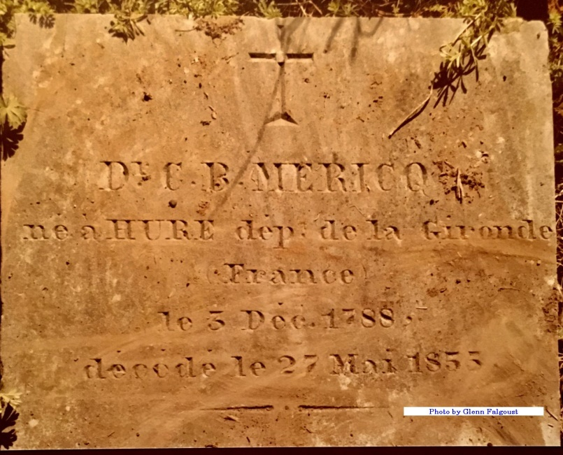

Contributed by Dwayne Montz

On May 28, 1855, a large crowd came to the last resting place of a man who will inspire many profound and sincere regrets in St. James and the surrounding parishes--this man is Doctor Cazimir Bernard Mericq. He was born in 1788 in the commune of Hure, in the Gironde department of France. Entering the college of Bazas at age 11, he left after having passed a rigorous course of studies. His father, who was a lawyer in the parliament of Toulouse, thus decided that his son would study medicine. Accepted as a doctor in the faculty of medicine of Paris in 1812, Cazimir graduated and became Major Surgeon of the third light calvary regiment of the Imperial Army. During all of his military campaigns he distinguished himself by displaying so much courage, humility, and zeal as a surgeon that he was recognized by the army.

In 1815, after the disaster of Waterloo, he left the military and departed for America. After arriving in Louisiana, he lived for several years on the Red River, and it wasn't until 1830 that he came to reside in our parish, where during 25 years he practiced medicine with skill and talent that will continue to be remembered as his legacy. For him, a man of the Heart and of humility, medicine was a vocation; thus was his life filled with good deeds and noble actions. God will receive his soul in the rest of the Just, for he was honest and good. He was a previous owner of the St. Joseph Plantation home in Vacherie, Louisiana. Dr. Mericq's work included the caring for the families, hired hands and indentured servants of the many local plantations.   
The tours of St. Joseph Plantation include a visit to his office which contains much of his medical equipment. Dr. Mericq died on May 27, 1855.

Unknown source  
Contributed by Ronald