Ethel (Leblanc) Millet

January 22, 1943 – April 16, 2013

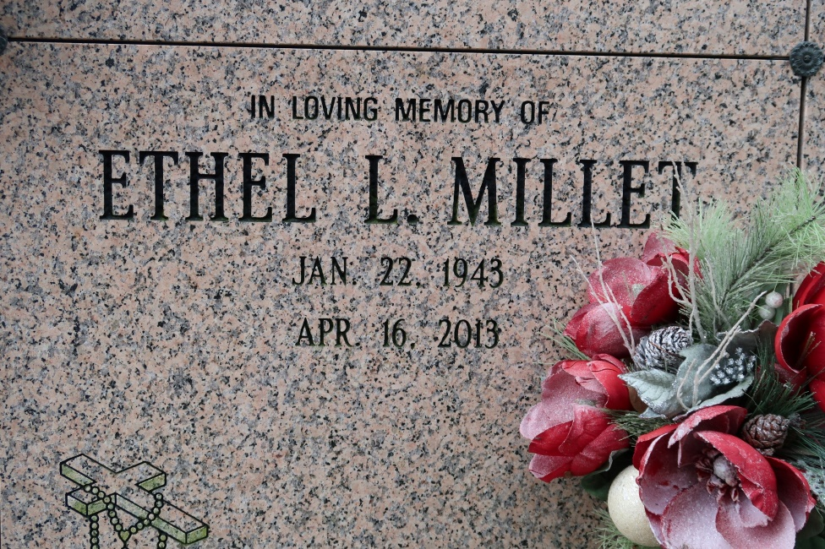

Ethel Leblanc Millet, 70, died on Tuesday, April 16, 2013 surrounded by her loving family. She is survived by her loving husband of 54 years, Ronald Millet; two daughters, Cheryl Millet Breaud and Stacy Millet; two sons, Brian Millet and Wade Millet; eight grandchildren, Jade Folse, Lindsay Antolik, Justin Breaud, Evan Breaud, Brianna Millet, Lacey Dempster, Ashlynn Dempster and Misty Veverka; three great grandchildren, Mayson Antolik, Ryan Braasch and Addison Veverka; and sister, Judy Schexnayder, wife of Johnny Schexnayder.

Preceded in death by her parents, Adley and Leona Leblanc. Pallbearers will be Justin Breaud, Evan Breaud, Jeffrey Folse, John Antolik, Jaret Benoit and Johnny Schexnayder.

Visitation will be held on Thursday, April 18, 2013 at 9:00 a.m. until Mass of Christian Burial at 11:00 a.m. at St. James Catholic Church. Entombment to follow at church mausoleum. Officiated by Rev. Michael Miceli. Arrangements by Ourso Funeral Home in Donaldsonville.

Family would like to give a special thank you to Dr. Deborah Abernathy and St. Joseph Hospice, especially nurse Dawn. In lieu of flowers, please make donations to Sister Dulce Foundation, 17560 George O'Neal Road, Baton Rouge, La. 70817 or St. James Catholic Church, 6613 Highway 18, St James, La 70086.

The Advocate, Baton Rouge, Louisiana

April 17 - 18, 2013