Ronald Joseph Millet
September 19, 1938 – February 12, 2025

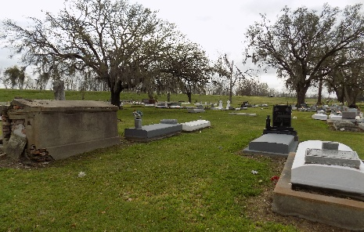

Ronald Joseph Millet, 86, passed away on February 12, 2025 at 11:30 am. Ronald was born on September 19, 1938 in Lagan, LA to parents Felicien and Marguerite Babin Millet.
Friends and family will be received at Saint James Catholic Church in St. James, Louisiana 70086 on Thursday, February 20, 2025 from 9:00 AM until service time. A funeral service will begin at 10:30 AM at the church with burial in the church cemetery.
Ronald is survived by his wife, Merline Brazan Millet; children, Brian Millet (Kim Beetz), Cheryl Millet Breaud, Wade Millet, Stacy Millet; sister, Diane Townsend; and numerous loving grandchildren, great grandchildren, great great grandchildren and step children, step grandchildren, step great grandchildren, and step great great grandchildren.
He is preceded in death by his first wife, Ethel LeBlanc Millet; parents, Felicien and Marguerite Babin Millet.
Ronald was an employee of Graugnard's Furniture since the age of 15. He was a very active parishioner of St. James Catholic Church.
The family would like to thank the staff of Thibodaux Regional Rehab, Haydel Memorial Hospice and his sitters for their exceptional care.
In lieu of flowers memorial donations may be the Dementia Society of America.

Ordoyne Funeral Home, Thibodaux, Louisiana

