Joan Mary (Folse) Morvant
January 18, 1933 - January 17, 2025

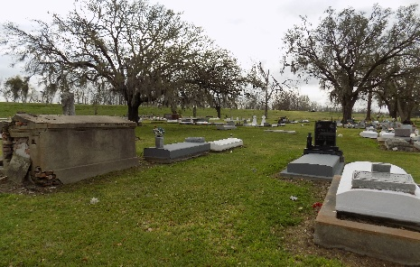

Joan Folse Morvant, 91, a native of St. James, Louisiana and resident of Vacherie, Louisiana passed away on January 17, 2025.
A visitation will be held on Saturday, February 1, 2025, at St. James Catholic Church 6613 LA Hwy 18 St. James LA from 8:00 AM until the memorial service at 10:30 AM. Burial will follow in the church cemetery.
She is survived by her sons, Keith (Niki), Craig, Joey (Leelee), David (Geraldine), and Dennis (Kathy) Morvant; daughters, Mary (Randal) Reulet and Michele (Richard) Fournier; twelve grandchildren, Jennifer, Tina, Dalton, Alesha, Brandi, Michael, Kobie, April, John, Taylor, David, and Heidi; seventeen great-grandchildren.
She was preceded in death by her husband, Wallace A. Morvant; parents, Walter and Gertrude Zeringue Folse; brothers, Frank, Ralph, and Bobby Folse; sister, Verdie LeBlanc; daughter-in-law, Johna Morvant; grandson, Nicholas Morvant; and great-grandson, Leland Granier.
She was the glue that held her family together. She loved all LSU sports, cooking, sewing and spending time with her family. She was an avid Christian, amongst her many loves was first her faith in Jesus.
The family wishes to thank the staff of ACG Hospice and Thibodaux Home Health. A special thanks to Tina Becnel, Mary and Randal Reulet, and Keith Morvant for their loving dedication to Mama Jo.
Mama Jo, to the world you are a mother, but to our family, you are the world.

Thibodaux Funeral Home, Lafourche Parish, Louisiana

