Wallace Antoine Morvant

September 16, 1928 – October 14, 2008

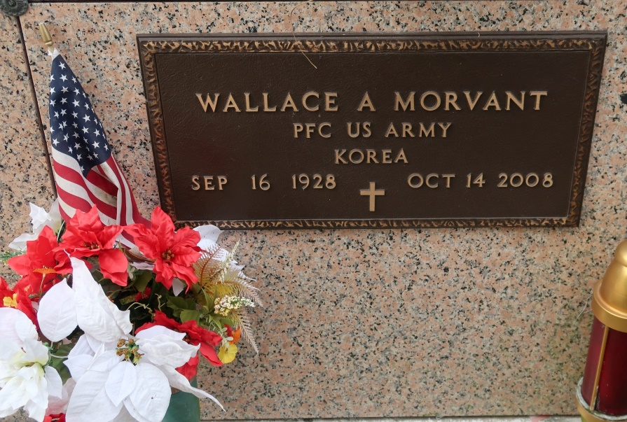

Wallace Antoine Morvant on Tuesday, October 14, 2008 at 8:42 p.m. in St. James, LA. Husband of Joan Folse Morvant, St. James, LA. Son of the late Wallace O. and Nora Millet Morvant. Father and father-in-law of Mary and Randal Reulet and Michele and Richard Fournier of Vacherie, LA; Keith and Darla Morvant, Enid, OK, Craig Morvant and Joey Morvant of St. James, LA; David and Geraldine Morvant, Thibodaux, LA and Dennis Morvant of Luling, LA. Grandfather of the late Nicholas M. Morvant. Brother of the late Irma Morvant Martin and Irving J. Morvant. Also survived by his devoted pet Bruiser and his best friend, pride and joy the late Taco "Puppie". Also survived by 12 grandchildren and 8 great-grandchildren. Age 80 years. A native and resident of of St. James, LA. He was a U.S. Army Veteran of the Korean Conflict.  
 Mass of Christian Burial at 10:00 a.m. on Saturday, October 18, 2008 at St. James Catholic Church, St. James, LA. Interment in Church Mausoleum. Visitation at the Church from 9:00 - 10:00 a.m. on Saturday. Arrangements by Ourso Funeral Home, Donaldsonville, LA.

Times-Picayune, The (New Orleans, LA)

Friday, October 17, 2008