Gloria Mae Nelson

February 25, 1939 – December 21, 2018

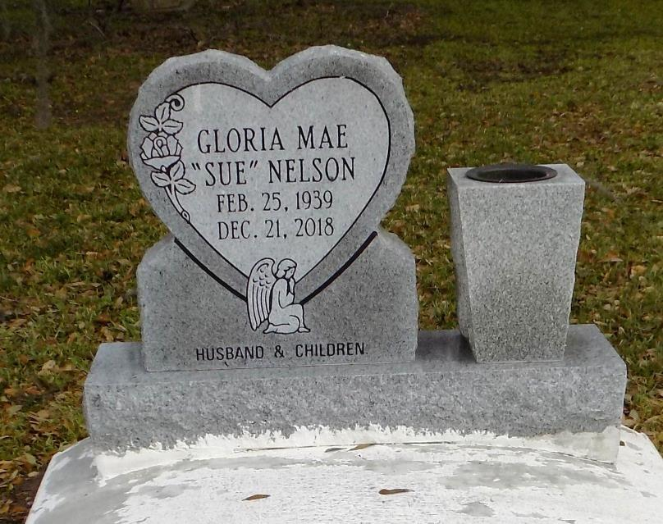

Gloria Mae “Sue” Nelson of St. James, Louisiana passed away on December 21, 2018 at Chateau D’Ville Rehab and Retirement of Donaldsonville, LA.

Gloria Mae Jeffery Nelson was born on February 25, 1939 to the late James and Erlen Jasmin Jeffery in Vacherie, LA. She was 79 years old at the time of her death.

Gloria Mae was a person with a great big heart. She was baptized at First Baptist Church by the late Rev. Lucien R. Garrett. She served her church, family, neighbors and community well, until her health started to decline. She had a great love for the Lord, you could find her many days praising and singing about her savior. She had a great love of First Baptist Church and her choir. Gloria spoke of the many road trips with Pastor Garrett and the choir to Rome and throughout the river parishes. She enjoyed spending time with her devoted husband Paul who she called Nell and her lovely children whom she adored. Gloria Mae was educated in the St. James Parish School System. She had a love for cooking and flowers. She was a chef and worked with one of the best, Chef John Folse for many years. Gloria Mae met and married the love of her life, Paul Nelson, Jr., and to this union 9 children was born: Bruce, Ricky, Ronnie, Wayne, Paul, Lelise, Angela, Troy and Randy Sr.

Gloria Mae leaves to cherish her memories her loving husband of 62 years, Paul Nelson, Jr., of St. James, LA; her six children: Bruce (Linda), Baton Rouge, LA; Ricky (Linda) Reserve, LA, Wayne, Paul (Patsy) Gonzales, LA, Angela N. Winchester, St. James, LA; Randy (Lolisa) of Vacherie, LA. Gloria also leaves her many grandchildren and great grandchildren. She also leaves her 2 devoted sisters, Lois J. Ferchaud (Alex) of Vacherie, LA and Iris J. Dumas (Dennis) of Gonzales, LA. Gloria leaves a devoted aunt, Dorothy Celestine of St. James, LA. Susie-Q leaves her godchildren, cousins and many nieces and nephews. She will be missed by best friends, Lydia M. Gloster, Marie Rodrigue, Joyclen W. Hayes and Theresa Keller.

Preceding her in death were her father, James Jeffery, her mother, Erlen Jeffery, her children, Ronnie, Troy and Lelise Nelson; her grandson James Kennedy, Jr; 3 aunts, Marjorie J. Stewart, Shirley J. Harrison and Emiley Jasmin; 3 uncles, Noltan, Louis and Vincent Jasmine; 2 best friends. Joyce P. Jasmine and Pearl Winchester; mothers-in-law, Mercedes and Ethel Nelson and father-in-law, Paul Nelson, Sr.  
 Funeral services will be held on Saturday, December 29, 2018 from First Baptist Church of Vacherie; 1244 Magnolia Heights. Vacherie, LA 70090. Rev. Johnnie Magee, Jr. Pastor-Officiant. Interment St. James Catholic Church Cemetery, St. James, LA. Treasures of Life Funeral Services entrusted with her final care. 315 E. Airline Hwy, Gramercy, LA 70052.

Treasures of Life Funeral Services, Gramercy, Louisiana