Harry Charles Nicholas

November 26, 1931 – October 18, 2000

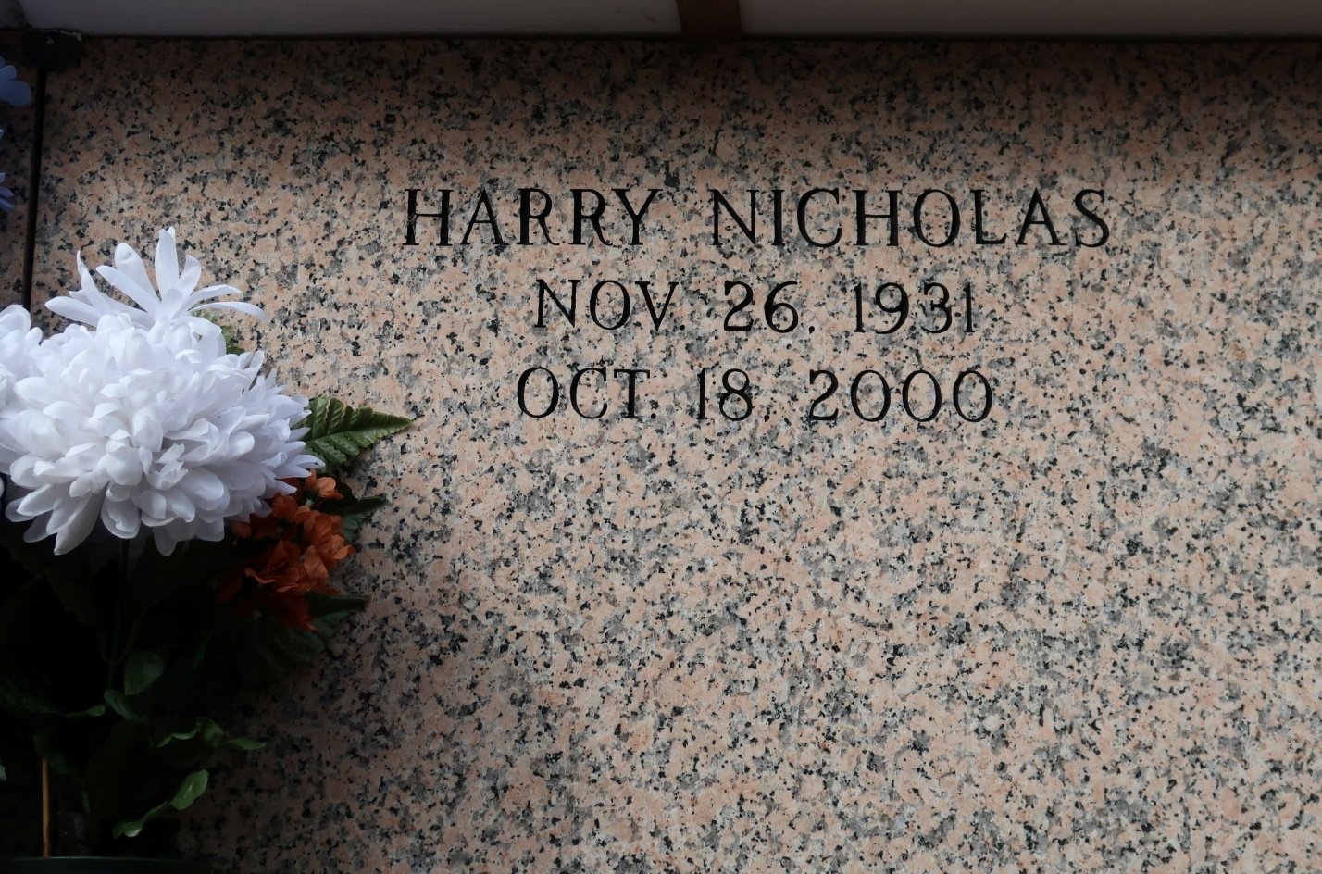

Harry Charles "Fobb" Nicholas, 68, a native and resident of St.James, died Oct. 18. He was the son of the late Carroll and Julia LanteyNicholas and brother of Marie Alexis, Edna Mathieu, Carroll Jr., Herman andWarren Nicholas and the late Eloise Sims and Earl and Russell Nicholas.  
  
Services were Oct. 26 at St. James Catholic Church, St. James, withinterment at the church mausoleum.

L'Observateur (La Place, LA)

Saturday, October 28, 2000