Henry Joseph Ordoyne Jr.
June 18, 1948 – December 4, 2022

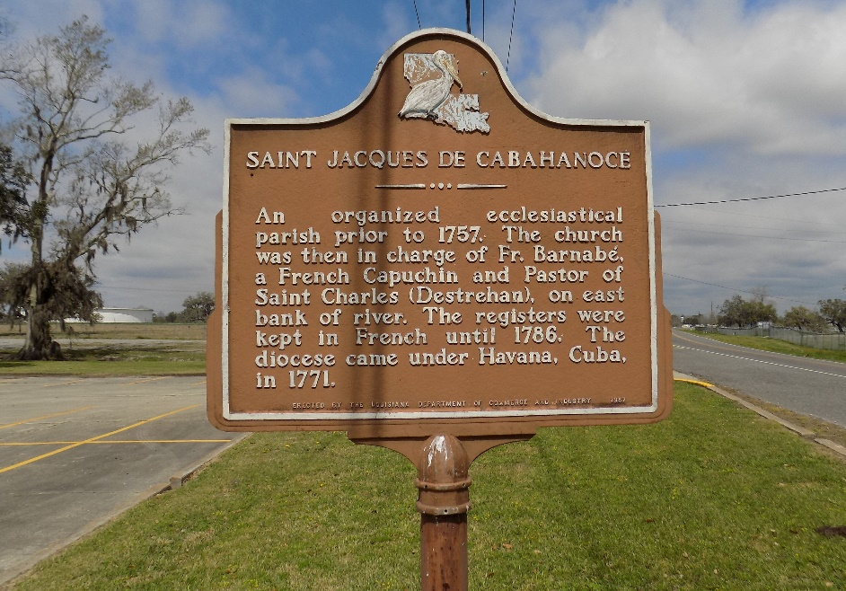

Henry Joseph Ordoyne, Jr. of St. James, passed away December 4, 2022 at the age of 74. He was born in St. James, LA, in 1948. Henry married Julie David on December 3rd 1983, in Vacherie LA.
Henry led a life of service to his country, his family, and his community. Henry proudly served his country in the United States Army for 28 years, retiring in 1996 as a 1st Sergeant of the 321st MMC at Baton Rouge. Henry worked for 59 years as a faithful employee of Graugnard Furniture stores. As an appliance repairman, he enjoyed helping people and getting to make many friends throughout the communities he serviced. Henry was a dedicated St. James High School Football supporter, having spent many seasons following the team, cooking for the concession stand, and feeding the football team his famous jambalaya every chance he got. Henry enjoyed spending time volunteering for various community events and was happiest when he was feeding people. Henry spent the last months of his time here on earth living his absolute best life and making memories that his family will cherish forever.
He is survived by his wife, Julie David Ordoyne; children, Chad Ordoyne (Melony), Cindy Ordoyne (John), Danielle Ordoyne, Henry Ordoyne III, and stepson, Jason Glaviana; grandchildren, Hunter Perez, Gracie Theriot, Ashley Glaviana and Zachary Glaviana; sister, Marie Ordoyne Holdum; brother, Claude Ordoyne (Faye); sister-in-law, Crystal Faucheux (Glenn); brother-in-law, Frank Musso (Patricia); and many nieces and nephews; and his best sidekick and buddy, his dog BooBoo.
He is preceded in death by his parents, Henry Sr. and Marie (Tabor) Ordoyne; brother, Thomas Ordoyne; brother-in-law, Billy Holdum, and sister-in-law, Joanna Brewer.
Funeral services will be Tuesday December 13, 2022 at St. James Catholic Church, 6613 LA-18, St James, LA 70086. Visitation 8:30 am - 11:00 am. Funeral Mass 11:00 am.

Rabenhorst Funeral Home, Baton Rouge, Louisiana
Dignitymemorial.com

