Fabiola (Crowley) Pierre

March 5, 1923 – November 15, 2012

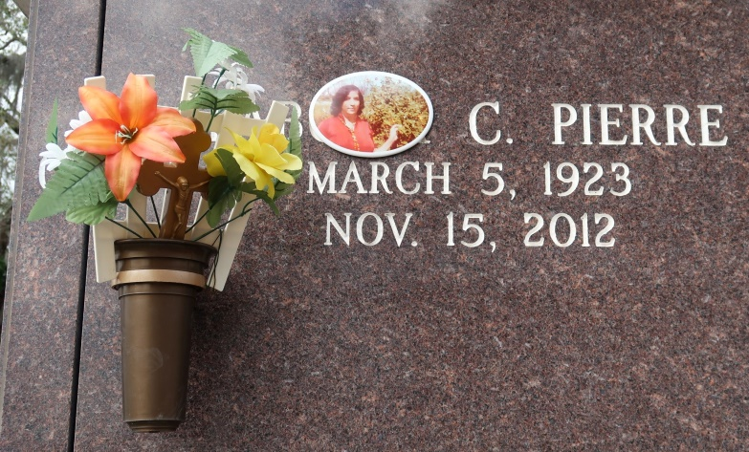

Fabiola Crowley Pierre departed this life on November 15, 2012, at the age of 89 years old. Daughter of the late Dempsey Crowley, Sr. and Camielle Wilson.. Wife of the late Elex Pierre, Sr. Mother of Marion (the late Lionel) Williams, the late Rosemary Pierre, the late Alex (Marilyn) Pierre, Richard (Wanda) Pierre, the late Deloris (Stanford) Jeffery, Joyce (Edmond) Morton, Sr., Rev. Douglas (Wanda) Pierre, Shelia (the late Glenn) Melancon, Sr., Bernard (Zena) Pierre, Michael (Quinna) Pierre, Kathleen Pierre (Clarence Williams), Jerome Pierre. Sister of the late Edna McQuarter, Ceola Collier, Grace Badelle, Joseph Crowley, Jr., and Jimmy Crowley. Also survived by a host of grandchildren, nieces, nephews, cousins, other relatives and friends.  
  
 Relatives, friends and surrounding churches are invited to attend funeral services at St. James Catholic Church, 6613 Louisiana Highway 18, St. James, La. on Monday, November 19, 2012 at 11:00 a.m. Father Christopher Decker will be officiating. Visitation will be from 9:00 a.m. until time of service. Burial will be at St. James Catholic Church Cemetery. Funeral services entrusted to The Baloney Funeral Home, LLC., 399 Earl Baloney Street, Garyville, La, 985-535-2540. Condolences can be expressed at [www.baloneyfuneralhome.com](http://www.baloneyfuneralhome.com).

Times-Picayune, The (New Orleans, LA)

Sunday, November 18, 2012