Lawrence Poche Jr.
1948 – October 10, 2014

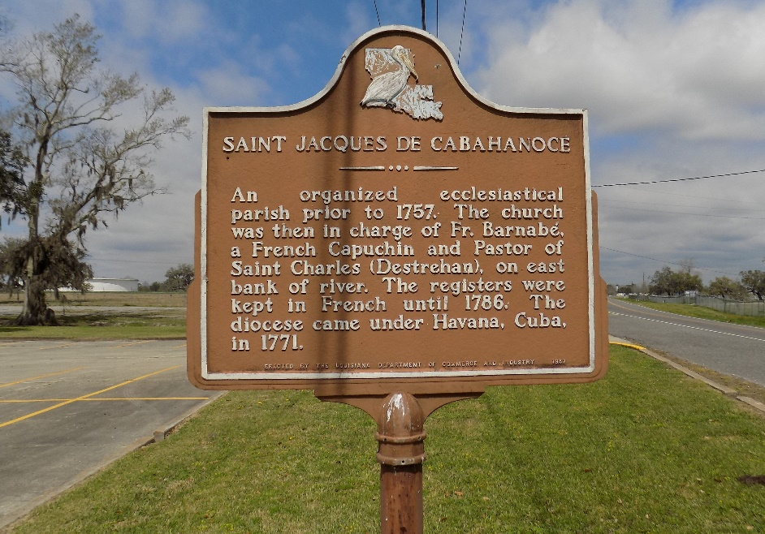

Lawrence "Tanut" Poche, Jr. entered into eternal rest on Friday, October 10, 2014, at the age of 66 years old. Son of the late Eunice Armant and Lawrence Poche, Sr. Devoted husband of the late Barbara Heary Poche.
Godfather of the late John "Duke" Stewart Jr., Charles Armant, Ericka Schexnayder Brignac, Cameron Stewart, and Ashley Burrell. Brother of Colonel (Linda) Poche, Leroy (Ursula) Poche, Catherine Bennett, Harold Poche, and Linda Poche. Also survived by a host of aunts, uncles, sisters-in-law, brothers-in-law, nieces, nephews, cousins, and other relatives and friends.
Relatives, friends and employees of Avondale Shipyard (Northrop Grumman), Walmart, and St. James Parish School Board are invited to attend a Mass of Christian Burial on Friday, October 17, 2014, for 11:00 a.m. at St. James Catholic Church, 6613 Highway 18, St. James, LA. Father Christopher Decker will be officiating. Visitation will be from 8:30 a.m. until time of service. Interment will be at St. James Catholic Church Cemetery, St. James, LA.
The Advocate, Baton Rouge, Louisiana
Oct. 16 to Oct. 18, 2014

