Eva Mae Marie Poirrier

September 16, 1927 – September 10, 2016

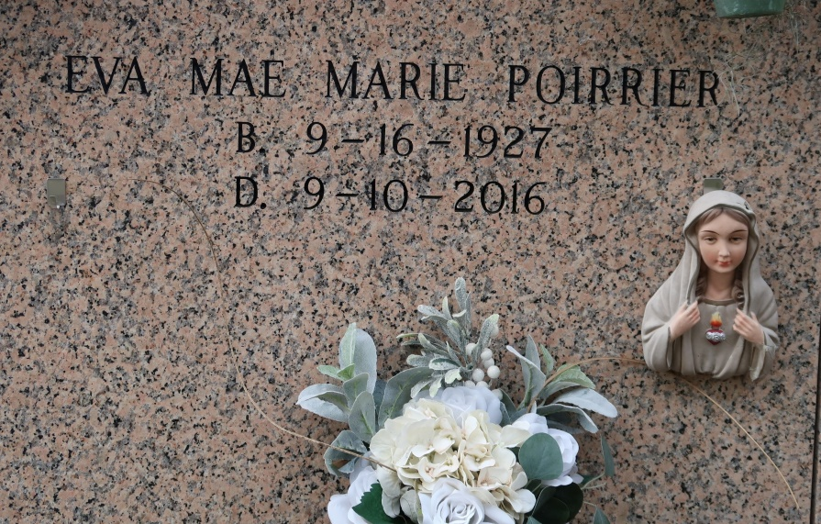

Eva Mae Poirrier, Fortified with the Sacraments of Holy Mother Church, born on September 16, 1927, died peacefully, September 10, 2016, at Ratliff Care Center in Cape Girardeau, MO. Eva Mae was born in Welcome, LA., Daughter to Wright and Leah Arceneaux Poirrier. She worked for the Louisiana Department of Public Welfare (1949-1979) and retired after thirty years of service. After retirement she was a bookkeeper for Welcome Plantation Inc. She also volunteered at the Welcome Senior Center and the St James Catholic Church, spending her time generously caring and praying for family and friends. She was a life time member of St Francis Hospital Auxiliary in Cape Giradeau, Mo.

Survivors include her sister in law Sophia Killian Poirrier, a niece LaDonna Poirrier Hengst (Richard), two grandnieces Michelle Ross (Steven), LeAnne Graham (Justin), and a grandnephew Grant Hengst, two great grandnieces Brenna Graham, Anna Ross, and two great grand nephews, Alexander Turner, and Colton Graham. She was preceded in death by her parents, three brothers, Wright "JP" Poirrier Jr., Louis Poirrier, James Poirrier and two sisters Leona Poirrier, Alice Poirrier.

Ourso Funeral Home in Donaldsonville, LA., is in charge of arrangements.   
Visitations will be held at St James Catholic Church in St James, LA on Thursday, September 15, 2016 from 10am until Mass of Christian Burial at 11am. Interment to follow in Church Mausoleum.

Unknown source