Joseph Alan Prichard

October 2, 1961 – December 30, 2012

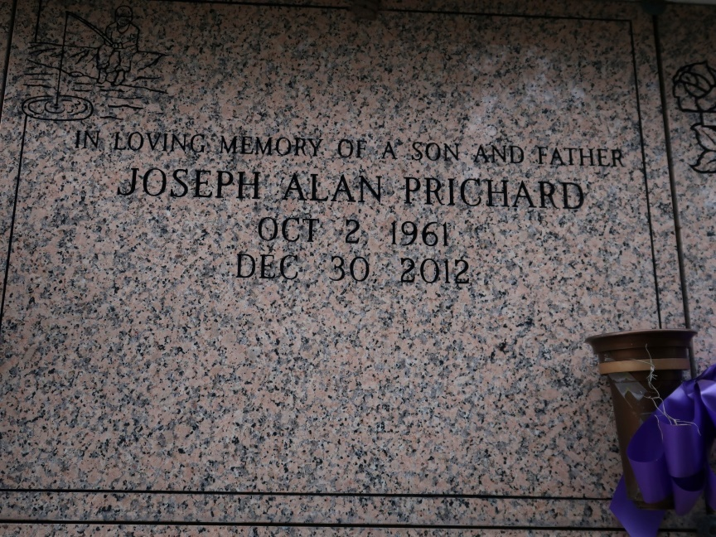

A native of West Hamlin, West Virginia and a resident of Baker. He died at Our Lady of the Lake in Baton Rouge on Sunday, Dec. 30, 2012. He was 51.

Visiting at St. James Catholic Church on Monday, Jan. 7, 2013 from 9 a.m. until Mass of Christian Burial at 11 a.m. conducted by the Rev. Michael Miceli. Entombment in St. James Catholic Church Mausoleum, St. James.

Survived by his wife, Rhonda McDaniel Prichard; his mother, Mary Zeringue; three daughters, Amy and Alicia Grainier, and Ellen Prichard; a son, Derek Prichard and wife DeShawn; six brothers, Lester Prichard, Jr., Timothy Efird, Clifford Efird, Arden Prichard and wife Teresa, Doug Prichard and wife Della, and Alan Prichard and wife Darlene; four sisters, Anita Spears (Darrin), Vanita Turley, Linda Thompson and Tina McMann; seven grandchildren, nieces, nephews, cousins, other relatives and friends.

Preceded in death by his father, Lester L. Prichard, Sr.; a brother, Denver Prichard; and a daughter, Kristin Grainier. Brazier-Watson Funeral Home in charge of arrangements

The Advocate, Baton Rouge, Louisiana

January 4 - 7, 2013