Edward Joseph Rodrigue

October 27, 1945 – May 11, 2001

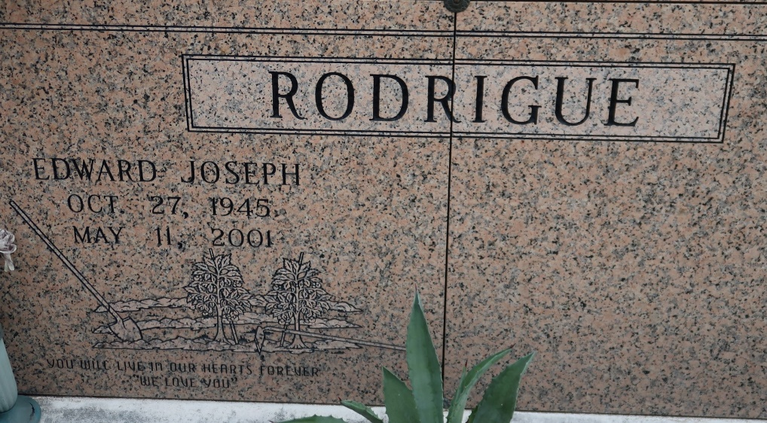

Edward Joseph Rodrigue, 55, a native and resident of Vacherie, died at 1:07 p.m. Friday, May 11, 2001.

Visitation was scheduled from 7 a.m. to funeral time today at St. James Catholic Church in St. James. Mass was scheduled for 10 a.m. today at the church, with burial in the church cemetery.

He is survived by his wife, Debra Bellow Rodrigue; one son, Adam Rodrigue; two brothers, Alwin and Errol Rodrigue; and four sisters, Betty falgoust, Sheila Haydel, Janet Motes and Charlene Hutchings.

He was preceded in death by his parents, Victor and Maebelle Guidry Rodrigue; and one brother, Robley Rodrigue.

He was a parishioner of St. James Catholic Church.

The Courier (Terrebonne Parish, LA) on Houmatoday.com