Ida Mae (Cayette) Schonberg

November 20, 1916 – November 4, 2014

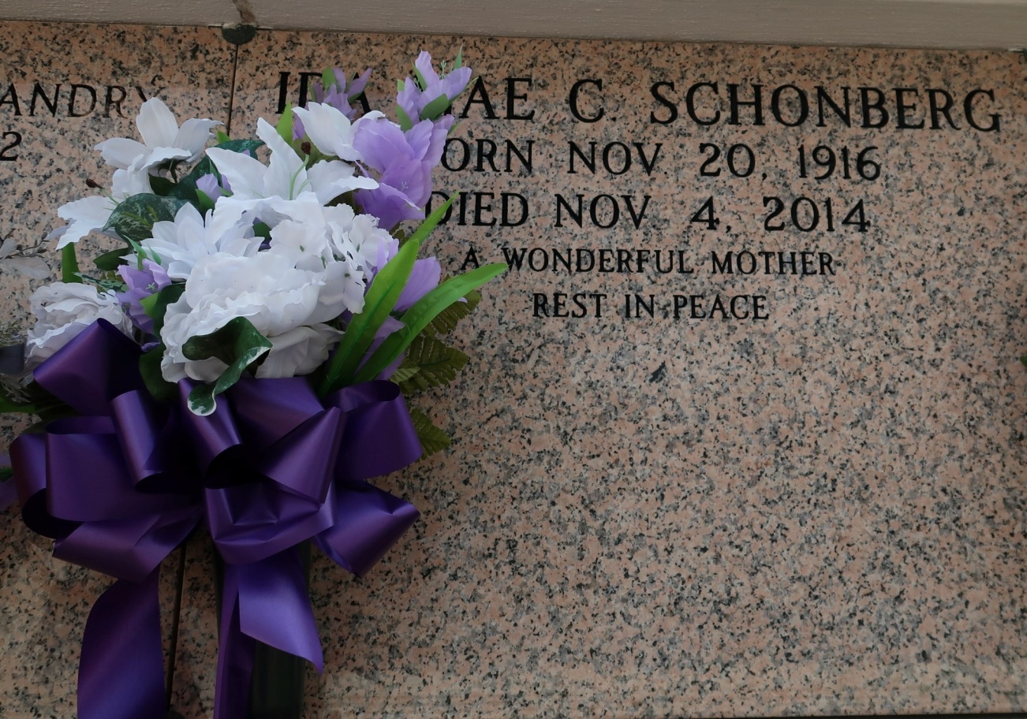

Survived by a daughter, Eleanor S. Sherman. A son, Earl B. Schonberg, and wife, Elsie. A brother, Carroll J. Cayette, Sr. A sister in law, Jeanne S. Domingue, seven grandchildren, twelve great-grandchildren, 15 great-great-grandchildren, numerous nieces, nephews, cousins, other relatives, and friends.

Preceded in death by his parents, Ernest Cayette, Sr, and Alphonsine Ganier Cayette; her husband, Allen B. Schonberg, and three brothers: Arthur O. Johnson, Ernest Cayette, Jr, and Harden Cayette.

Unknown

\*\*\*\*\*

Ida Mae Cayette Schonberg, a native of St. James and a resident of Belle Rose, passed away at her daughter's residence in Belle Rose at 4:00 a.m. Tuesday, Nov. 4, 2014. She was 97.

Visiting at St. Catherine of Sienna Catholic Church, St. Patrick Street, Donaldsonville, Tuesday, Nvember 11, 2014, from 9:30 a.m. until Mass of Christian Burial at 11:00 a.m. conducted by the Rev. Desmond Ohankwre, M.S.P. Entombment in St. James Catholic Church Mausoleum in St. James.

Survived by a daughter, Eleanor S. Sherman. A Son, Earl B. Schonberg And Wife, Elsie. A Brother, Carroll J. Cayette, Sr. A Sister In Law, Jeanne S. Domingue. seven grandchildren, twelve great grandchildren, fifteen great-great grandchildren, numerous neices, nephews, cousins, other relatives and friends.

Preceded in death by her parents, Ernest Cayette, Sr., and Alphonsine Ganier Cayette. Her husband, Allen B. Schonberg and three brothers, Arthur O. Johnson, Ernest Cayette, Jr. and Harden Cayette.   
 Brazier-Watson Funeral Home in charge of arrangements. Visit us at www.brazierewatson.com to sign our guest book.

Advocate (The) Baton Rouge, LA

Saturday, November 8, 2014