Lionel Spencer

April 13, 1938 – March 18, 2014

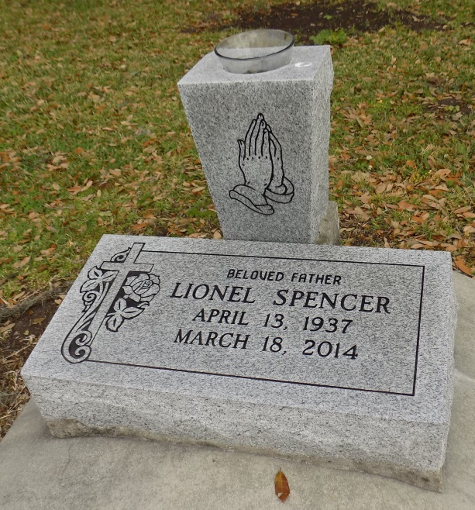

Lionel "Gator" Spencer - A native and resident of St. James, he passed away on his residence at 7:00 a.m. on Tuesday, March 18, 2014. He was 75.

Visiting at St. James Catholic Church, St. James, Monday, March 24, from 9 a.m. until religious services at 10 am. conducted by Rev. Christopher Decker. Interment in church cemetery.

Survived by a daughter, Leah Mitchell; three sisters, Philadee Monconduit, Alvenia Rodrigue, and Janie Mae Sutherland;l numerous nieces, including Dianne and Janie Spencer, and a sister-in-law Gladiola Spencer, nephews, cousins, other relatives and friends. Preceded in death by his parents, Shedrick Spencer, I, and Rowena Joseph Spencer; two brothers, James and Shedrick Spencer II; and six sisters, Ethel, Aline, Sedonia, and Selena Chiquet, Frances Rodrigue and Alice Heary.

Brazier-Watson Funeral Home, Donaldsonville, in charge of arrangements

The Advocate, Baton Rouge, LA

Saturday, March 22, 2014  
Contributed by Jane Edson