Annette (Fefie) Spurlock

January 23, 1959 – June 9, 2004

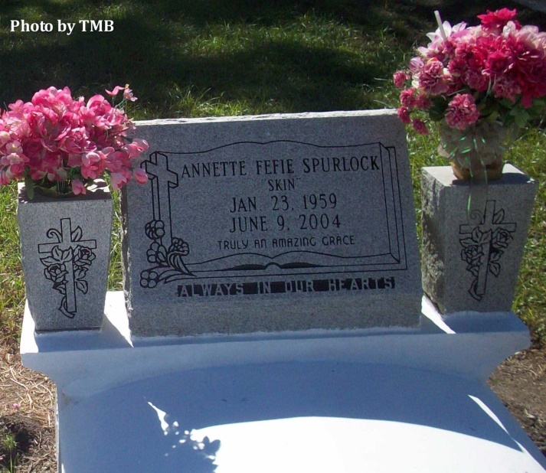

A supervisor at Sunrise Human Development Agency and a resident of Donaldsonville, was 45 and a native of St. James. Survived by a devoted friend, Roger McKenney; former husband, Earl Spurlock; a daughter, Amber Spurlock, Donaldsonville; a son, Aaron McKenney, Donaldsonville; four stepsons, Merrick and Derrick McKenney, both of Modeste, and DeRog and Germaine Flowers, both of White Castle; eight sisters and three brothers-in-law, Mary F. Fefie, New Orleans, Rita H. Fefie, Betty F. and Robert Jones, Odette M. Fefie, Marilyn F. and Eugene Sutherland, Antionette F. and Lionel Simmons, all of St. James, Doris F. Truehill of Labadieville and Theresa C.F. Zenon of Hawthorne, Calif.; and two brothers and a sister-in-law,   
Joseph Fefie of St. James and Cleveland and Monica Fefie of Donaldsonville. Preceded in death by her parents, Alonzo P. and Beatrice F. Fefie

Unknown source

\*\*\*\*\*

Authorities say Belle Rose man kills girlfriend, himself

DONALDSONVILLE - A Belle Rose man shot and killed his girlfriend in a downtown social services office Wednesday before committing suicide with the same pistol, Ascension Parish sheriff's investigators said. Annette F. Spurlock was working in her office about 9 a.m. at Sunrise Human Development Agency on Railroad Avenue when Brad Lemon entered while pointing a 9 mm pistol, sheriff's Lt. Col. Paul Robert said. Lemon killed Spurlock, 45, 109 Burns Drive, Donaldsonville, by firing three bullets into her chest, Robert said. Lemon, 29, 164 Daggs St., shot himself in the head after fatally wounding Spurlock, Robert said. The bodies of Spurlock and Lemon were taken out of the office just before 11:30 a.m. and sent to Earl K. Long Medical Center in Baton Rouge for autopsies. Robert said deputies received a call around 9:18 a.m. from someone who heard shots fired at the social services office. An employee at Sunrise said he heard Lemon and Spurlock arguing and then he heard gunshots, Robert said. The employee ran out of the building as the rounds went off and called the Sheriff's Office. Robert said Spurlock and Lemon were not married, and the Sheriff's Office had no records of domestic violence involving either of them. "Neither one of them were in our system," Robert said. Robert said that acquaintances of the couple told deputies that Lemon and Spurlock had been seeing one another for about eight months. The friends described Lemon as being more serious about the couple's relationship than Spurlock, Robert said. "Everything here points to a murder-suicide, so there is no assistant to go after," Robert said.

Many members of Spurlock's family, gathered in shock and grief outside of City Hall just before noon Wednesday after authorities drove the bodies away from the scene. But none of Spurlock's relatives wished to talk about her or what happened. Spurlock was employed as a field representative at Sunrise, a nonprofit corporation operating in Donaldsonville, Robert said. Sunrise offers counseling services to the public on matters including parenting and how to cope with problems of alcohol and drug abuse.

The Advocate, Baton Rouge, LA

Thursday, June 10, 2004  
Contributed by Jane Edson