Glenda (Himes) Washington
1944 – July 21, 2024

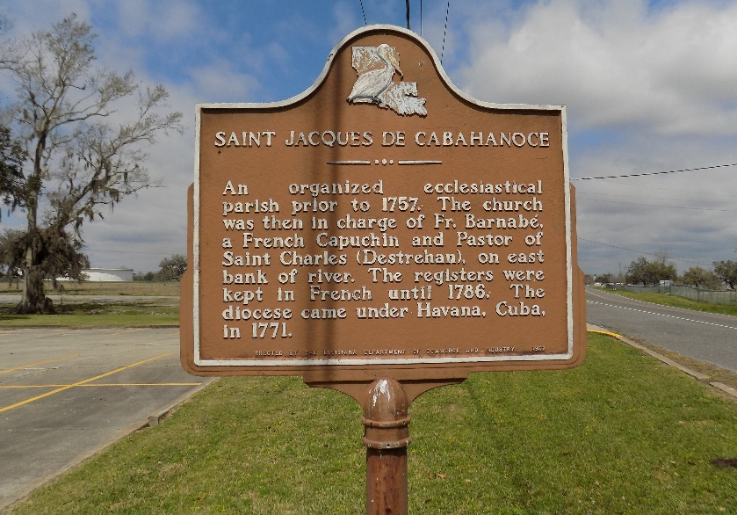

Glenda Himes Washington departed this life on Sunday, July 21, 2024, at Baton Rouge General Hospital. She was 79, a native and resident of St. James, LA.
Visitation on Friday, August 2, 2024, Willams & Southall Funeral Home, 101 Loop 945, Donaldsonville, LA from 5:00pm to 7:00pm. Visitation on Saturday, August 3, 2024, at St James Catholic Church, 6613 LA-18 St. James, LA 70086, from 8:00am to religious services at 9:30am followed by Mass of Christian Burial at 10:30am. Entombment in the church mausoleum.
Survived by 2 daughters, Alicia Washington, and Tasha Sanders (John); 1 brother, Donald Himes (Cynthia); 1 sister, Patricia Lemieux; 4 grandchildren, Onesha Smith, Olaya Smith, Joy Sanders, Tyler Sanders; 1 great granddaugh-ter, Paisley Costly; a host of nieces, nephews, other relatives, and friends.
Preceded in death by her parents, Octave Himes and Anide Nicholas Himes; grandchildren, Oneal Smith, Jr., and 2 angels; 1 dear aunt, Leona Landor; 1 brother, Larry Himes; 1 sister, Linda Himes.

Williams & Southall Funeral Home, Donaldsonville, Louisiana

