Joseph Jonoid Weber

March 7, 1935 – September 16, 2016

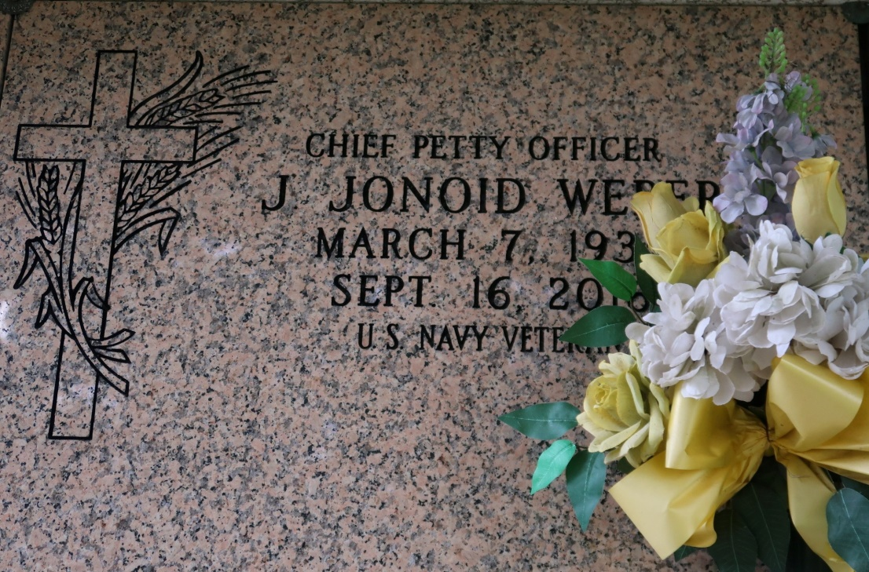

On 18 September, 2016, Joseph Jonoid Weber, 81 of Vacherie, peacefully departed this life at the Southeast Louisiana Veteran's Home. Born on March 7, 1935, the fourth of ten children to the late Matcolia and Roosevelt Weber, Jonoid, as he was known to family and close friends, attended Magnolia High School.

He joined the Navy at an early age and spent the next 20 years in a wide variety of sea and shore assignments that included Hawaii, Philadelphia, Newfoundland, and both Charleston, SC and Charleston, WV. While in WV he met and married the former Edna Meadows and to this union there were three children. He retired from the Navy as a Chief Petty Officer in 1971. Returning to Louisiana after the Navy, he still had the lure of the sea in his veins. He attained his river pilot's license and spent the next 23 years commanding the Vacherie-Lutcher Ferry earning him the nickname "Captain Weber."

Captain Weber was a stalwart member of the community who loved the blues, was an accomplished carpenter, an avid gardener, and could fix anything with a motor. He was a faithful member of Saint James Catholic Church and was a mainstay at Saturday evening Mass until health issues precluded his attendance.

Left to cherish Jonoid's memory are his wife Edna, sons Anthony (Lisa) of Laurel Maryland and Edmund of Gainesville, Florida, sisters, Jeanette Savoie (Charlie), Gwendolyn Cooper of Marrero, La., Vada Franklin (late JW) of New Orleans, La., Alinda Johnson (Rodney) of Vacherie, La., Sybil Nalls (Jimmy) of Franklin, TN., granddaughter Rhea Johnstone (Josiah) of Moore, Ok., grandsons Branden (Candace) of Frisco, Tx., Darius of Springfield, Va. and Devin Pedescleaux of Gonzales, La., great grandchildren, Micah, of Lakewood, CA., Zoe and Emmitt of Frisco, Tx., and a host of nieces and nephews, cousins, other friends and relatives.

He was preceded in death by his parents, his sisters Mercedes, Edith Steib (Sylvester), Brothers Clyde (Carolyn), Nedra, and daughter Jemma. Funeral arrangements entrusted to The Baloney Funeral Home, located at 1905 West Airline Hwy., LaPlace, LA. 70068 Relatives and friends are invited to attend a mass of Christian burial on Wednesday, September 21, 2016 at 11:00 a.m. at St. James Catholic Church, 6613 LA 18, St. James, La, 70086. Father Reuben Dykes celebrant. Interment in Church Cemetery. Visitation with family at the church begins at 9:00 a.m. Public Visitation will be held on Tuesday, September 20, 2016 from 2:00PM-5:00PM at The Baloney Funeral Home, located at 1905 West Airline Hwy. LaPlace, LA. 70068. Visitation at the Church begins at 8:30Am on Wednesday, September 21st, 2016 until time of service. Interment, St. James Cemetery. Funeral arrangements entrusted to The Baloney Funeral Home located at 1905 West Airline Highway, LaPlace, LA. 70068 (985) 224-8460.

The New Orleans Advocate, Louisiana

September 19 - 21, 2016