Raymond Paul Weber, Sr.
September 7, 1944 – August 12, 2025

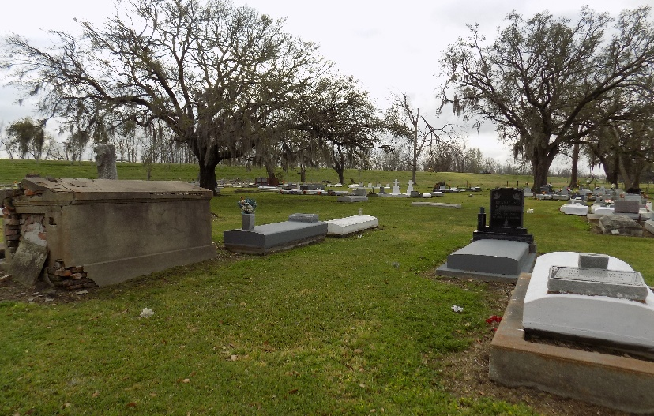

Raymond Paul Weber, Sr., affectionately known as Papa, was born on September 7, 1944, to the late Beatrice Oubre Weber and John (Snook) Weber, Sr. On August 12, 2025, the Lord Almighty dispatched His heavenly angels to bring His son home. Raymond was a devoted husband, father, great grandfather, and friend. He loved life, cherished his family, and poured his heart into everything he did. Raymond’s greatest joy in life was his family. In 2007, he married his faithful and devoted wife, Lisa Weber, who stood by his side through all of life’s moments. He deeply loved his children: Raymond Weber, Jr., Kalantha Weber, Kyler Weber, Shaun Jones, and Lance Jones. He especially adored his grandchildren: Denim, Drake, Savayon Quin’Tashza, Dai’Shanae, Takia, Da’Jon, Tahj, Kourtney, Skylar, Tyler, Teyana, and Shaydon. He was also blessed with four great-grandchildren: Yauri, Chance, Armani, and Laitlyn.
A proud graduate of Magnolia High School, class of 1961, Raymond went on to serve his country faithfully in the United States Army. Following his military service, he became a skilled and respected carpenter, known for building numerous homes throughout the tri-parish community. His passion for craftsmanship led him to co-found “Cousin’s Cabinets”, alongside his cousin Harry Oubre, Sr. He took great pride in showcasing his work and sharing his knowledge. Raymond enjoyed Nascar Racing, collecting antiques, watching the Kansas City Chiefs play football, listening to Etta James and the Williams Brothers gospel hymn “Cooling Water”.
He leaves to cherish his memories his loving wife Lisa, his five children, his grandchildren, his great-grandchildren, his mother-in-law, Natalie Braud; three sisters-in-law: Mary (Sonny) Ester, Lois Johnson, and Darlene Braud; five brothers-in-law: Lawrence (Lynette) Braud, Jr., Zachary (Betty) Braud, Kevin (Charlene) Braud, Nathaniel (Shandell) Braud, and Darren Braud; eight godchildren, and a host of nieces, nephews, extended family members, and dear friends.
Raymond was preceded in death by his son Sidney Eugene Jones, Jr., his parents: John and Beatrice Weber, stepmother Melvina Weber; sister Stephanie Weber; brother John Weber, Jr.; his father-in-law Lawrence Braud, Sr.; his brother-in-law Israel Evans, Jr.; his sister-in-law Helena Weber; and niece Robin Weber.
A Mass of Christian Burial will be held on Saturday, August 23, 2025, at St. James Catholic Church, 6613 LA-18, St. James, LA 70086; visitation from 8:30-10:30am followed by Mass for 10:30am. Private burial.

Treasures of Life Funeral Services, Gramercy, Louisiana
August 23, 2025

