Mildred (Octave) Whittington

October 13, 1925 – July 28, 2010

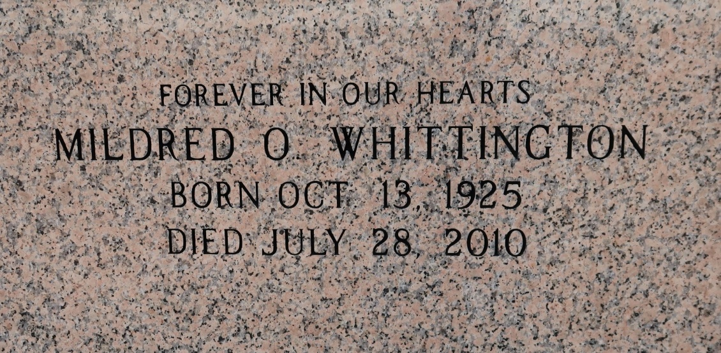

A homemaker and resident of Donaldsonville, she died Wednesday, July 28, 2010, at home. She was 84 and a native of St. James. All arrangements are at St. Catherine of Sienna Catholic Church, Donaldsonville, on Saturday, Aug. 7., with visitation at 9 a.m., a recitation of the rosary at 9:30 a.m., a celebration of life at 10 a.m., and Mass of Christian Burial at 11 a.m., celebrated by the Rev. Ayo Emmanuel Efodigbue. Entombment in St. James Catholic Church Mausoleum.

She is survived by five daughters, Glyndloyn Cosey, Mildred Armstrong, Trena Washington, Wanda Waldrup and Ericka Sims; three sons, Malcolm Whittington, Joseph Whittington Jr. and Eric Whittington; two brothers, Willie Octave Sr. and Arthur Octave Jr.; 15 grandchildren and 13 great-grandchildren.

She was preceded in death by her parents, Arthur Octave Sr. and Alverine Octave; loving husband, Joseph Whittington Sr.; and granddaughter, Cynthia Wesley. She loved caring for her family. Arrangements by Demby & Son Funeral Home, Donaldsonville, (225) 473-9534.

The Advocate, Baton Rouge, Louisiana

August 6, 2010