Alvin Williams

October May 17, 1942 – October 24, 2020

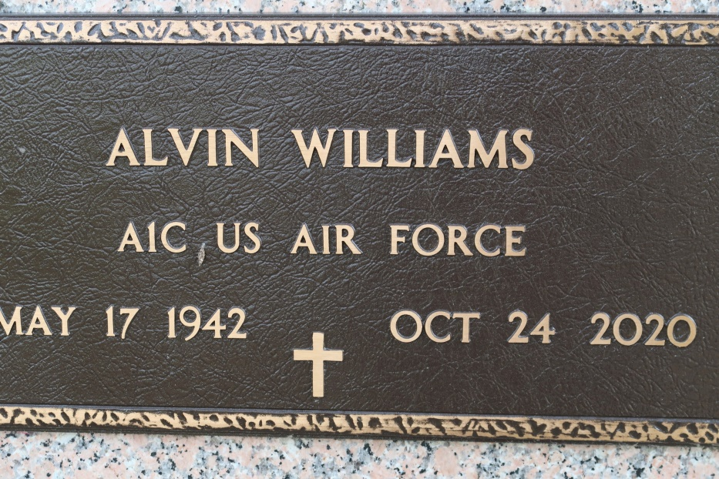

A native of St. James and a resident of Spring, TX. He passed away at Open Hands Personal Care Home in Spring, TX on Saturday, October 24, 2020. He was 78.

Visiting at the Funeral Home, 623 Railroad Avenue, Donaldsonville, from 2:00 until 5:00 p.m., Monday, November 2, 2020. Visiting continues at St. James Catholic Church, St. James, Tuesday, Nov. 3, 2020 from 10:30 a.m. until Mass of Christian Burial at 11:00 a.m., conducted by The Reverend John Du. Entombment in church mausoleum. Masks are Required At All Times.

Survived by step-daughters, Consuella Encalade and Tammy (Larry) Cloud. Sisters, Carliss (James) Walker and Marcia (Haratio) Rapp. Brothers, John (Marie) Gantt, Keith (Debbie) Williams and Bryce (Paula) Harris. Also survived by numerous grandchildren, great grandchildren, an aunt, Helen Nelson, nieces, nephews, cousins, other relatives and friends.

Preceded in death by his parents, John Williams, Sr. and Hilda Nelson Williams. His wife, Rita Wright Williams. Step-daughter, Yolanda Owens. Brazier-Watson Funeral Home in charge of arrangements.

Tributearchive.com