Maude M. Winchester

September 23, 1921 – September 27, 2006

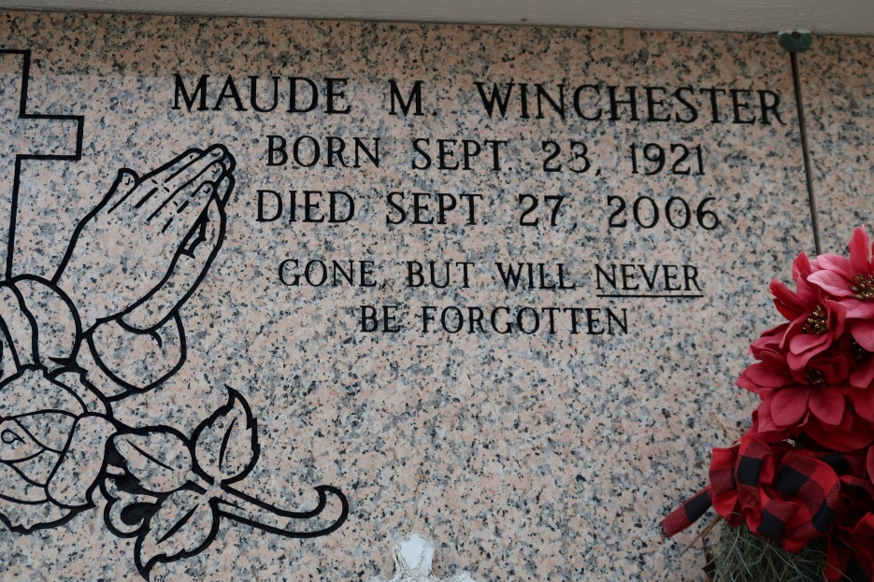

Maude Winchester, of St. James, LA, on Wednesday, September 27, 2006 at Baton Rouge General Hospital. Daughter of the late William and Clothilde Lantey-Winchester. Sister of the late Murphy (Banks), Clarence, Ulysses and Junius (Te Calais) Winchester, Clothilde, Osteal, twin-Marjorie Winchester, Alice W. Landry, Ruby (Joseph) Jackson and Eunice (Victor Sr.) Nelson. Devoted great-aunt of Nadine (Machiavelli) Nelson-Cooper, Nydia Maude Marie Cooper and Johannces Baptiste. Devoted aunt of Berita Nelson-Leonard. Godmother of Mercedes Chopin and Victor Nelson, Jr. Survived by 4 nieces, 2 nephews, great-nieces and -nephews, cousins and friends. A native and resident of St. James, LA.

Relatives and friends of the family; also priest and parishioners of St. James Catholic Church, neighboring churches; and members of Rising Sun Society are invited to attend a Mass of Christian Burial on Monday, October 2, 2006 at 10:00 a.m. from the St. James Catholic Church, St. James, LA. Father Louis Oubre, celebrant. Entombment Church Mausoleum. Visitation at the Church after 8:30 a.m. Recitation of the Rosary at 9:00 a.m.

Arrangements entrusted to THE EARL BALONEY FUNERAL HOME, L.L.C. 399 Earl Baloney Dr., Garyville, LA 70051 Information: (985) 535-2540

The Times-Picayune (New Orleans, LA)

Oct. 1, 2006.