Norma Jean (Lewis) Winchester
March 24, 1952 - January 25, 2025

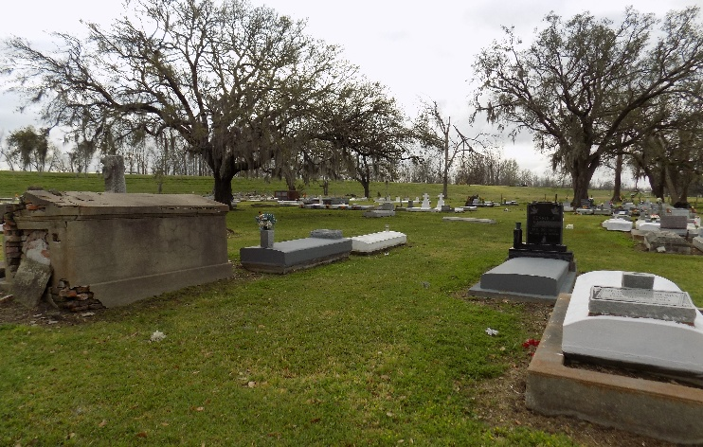

“Trust in the Lord with all thine heart; and lean not unto thine own understanding; in all thy ways acknowledge him and he shall direct thy paths.” Proverbs 3:5,6

Norma Jean Lewis Winchester, a wife, a mother, a daughter, a sister, and one of God’s faithful servants departed this life and was granted the wings of an Angel on January 25, 2025, at the age of 72 at her home. She was surrounded by the love of her family.
On March 24, 1952, in New Orleans, Louisiana, a beautiful baby girl named Norma was born to the late Toefield Lewis, Sr. and Laura Dennis Lewis. Norma Jean’s Christian journey began quite early, as she accepted and received Christ at a young age. She was a faithful and dedicated member of St. James Catholic Church. Norma loved the Lord and personified that love through the commentator and the Vacation Bible Study ministries in the church. She was a faithful and dutiful servant to the Lord. Her service extended beyond the walls of her church home. Norma was a faithful member of the Barras Street Bible Study Group where the doors were opened to anyone who needed prayer. She was one of the leaders in God’s army and devoted her time to help care for her niece and praying for her community.
Norma was a proud graduate of St. James High School, Class of 1970. She worked in a sewing factory as a seamstress. She was a dedicated retail worker for Duck’s Groceries for many years. Throughout her years of working retail, she touched and impacted the lives of many people. She was joyful, encouraging and well respected and loved by all who came in contact with her.
On July 19, 1971, she was united in Holy Matrimony to Sylvester J. Winchester, Sr. To this union three children were born, Brian A., Sylvester, Jr., and Ron T. Winchester.
Norma leaves to cherish her memories, her loving mother, Laura Dennis Lewis of St. James, LA; a loving and devoted husband, Sylvester J. Winchester, Sr.; three sons- Brian (Melanie) of Geismar, LA, Sylvester, Jr. of St. James, LA, Ron (Chasity) of Baton, LA; one bonus son- Delbert Gaines of Prairieville, LA; three granddaughters- Brejean Winchester of Geismar, LA, Diamond Winchester of St. James, LA, Kiah Winchester of Donaldsonville, LA; four grandsons- Brian, Jr. (Lynsey) of Denham Springs, LA, Ron, Jr. and Ronquell Winchester of Donaldsonville, LA, Chase Alexander of Gonzales, LA; one great grandson- Blaise Winchester of Geismar, LA; five bonus grandchildren- JaQuana Gaines of Prairieville, LA, Kiashonte Johnson of Donaldsonville, LA, Mikalyn, Mya and Braylon Nicholas of Baton Rouge, LA. She is also survived by her four brothers and 4 sisters, numerous nieces, nephews, cousins, other relatives and friends.
Norma was preceded in death by her father, Toefield Lewis, her brothers, Nelson, Freddy and Toefield Lewis, Jr., her sister, Helen Lewis, her father-n-law, John Winchester, her mother-n-law, Mary Whittington Winchester, her sister-n-law, Janel Gordon, and her brother-n-law, John Winchester, Jr.

Demby & Son Funeral Home, Donaldson, Louisiana

