Albert Paul Zeringue, Jr.

September 17, 1924 – January 3, 2005

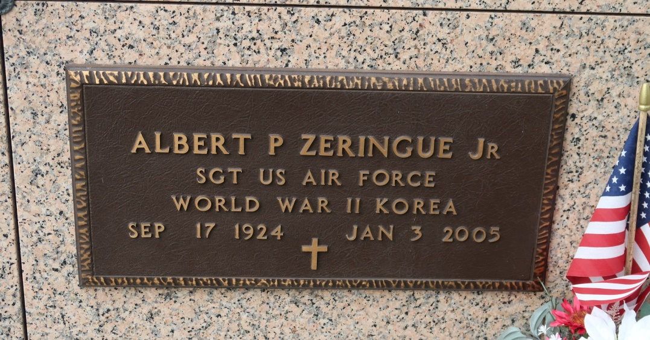

Albert Paul "Bear" ZERINGUE, a loving husband, father and grandfather, he went to be with the Lord at 5:20 pm Monday, Jan 3, 2005, at Our Lady of the Lake Regional Medical Center, Baton Rouge. He was 80, a resident of St. James and a retired clerk for St. James Co-op. He was a native of Modeste and a US Army veteran of World War II.

Visiting at St. James Catholic Church, St. James, from 9 am until Mass of Christian Burial at noon Wednesday, Jan 5, conducted by the Rev. Louis Oubre. Entombment in church mausoleum.

Survived by his beloved wife, Mary Puller Zeringue; two daughters, Linda Thompson and Tina Thompson McMann; four sons, Lester and Joseph Prichard and Timothy and Clifford Efird; three sisters, Ethel Oubre, Lillian Ledet and Anna Mae Ledet; two brothers-in-law, Riley Folse and Herman Ledet; 18 grandchildren, four great-grandchildren and numerous nieces, nephews, cousins and friends.

Preceded in death by his parents, Albert Sr. and Regina Waguespack Zeringue; and two sisters, Thersa Zeringue Folse and Aline Zeringue Becnel.   
 He was a member of St. James Welcome Citizens. Ourso Funeral Home, Donaldsonville, is in charge of arrangements

The Advocate, Baton Rouge, LA

Wednesday, January 5, 2005