Allen Francis Zeringue

March 21, 1933 – August 7, 2009

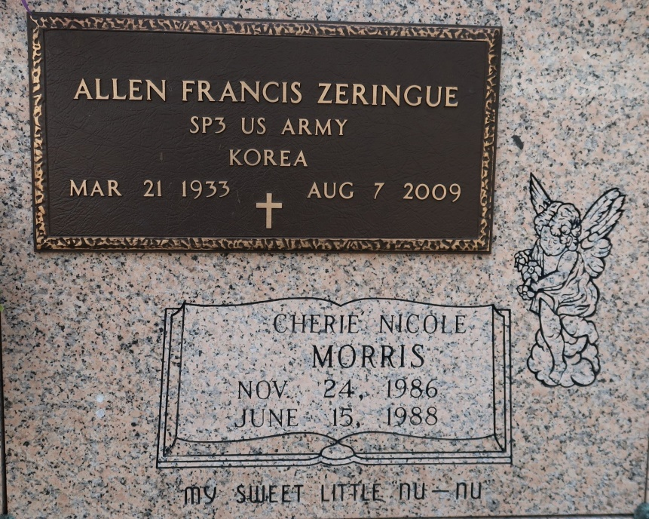

Allen Francis Zeringue, 76, a lifelong resident of St. James, passed away at his home on Friday, Aug 7, 2009. He was a wonderful husband and best friend of almost 53 years to Betty Amedee Zeringue, and loving father to Wanda and her husband, Kenny Morris, Randall and his wife, Jennifer, Charlene and her husband, Rudy Gravois, and Jason and his wife, Janice "Kim."

He was born on March 21, 1933, the fifth child of the late Furcy and Lea Zeringue, and the beloved brother of Stanley, Alfred and Robert Zeringue and Rita Mae Faulkner. He left behind seven grandchildren, Bret, Dusty, Christina, Kimberly, Danielle, Leah and Shelby; and three great-grandchildren, Nathan, Kyle and Kade. Preceded in death by his brothers, James and Nelson Zeringue; and granddaughter, Cherie Morris.

A veteran of the U.S. Army, Allen served in Germany and upon his return worked and provided a wonderful life for his family. He retired from Oxi-chem in Taft and since then has enjoyed traveling with his wife and friends, Cajun dancing with his dance groups, gardening and fishing. He was a member of the Knights of Columbus and served as an usher and Eucharistic minister at St. James Catholic Church. Truly a special person to all who knew him, he had a sense of humor and a personality that was truly unique and will be remembered and missed by all who knew and loved him.

Visitation at St. James Catholic Church, St. James, on Tuesday, Aug 11, from 8 am until Mass of Christian Burial at 11 am Entombment in the church mausoleum.   
In lieu of flowers, memorial donations can be made to the American Cancer Society, 10528 Kentshire Court, Baton Rouge, LA 70810

The Advocate, Baton Rouge, LA

Tuesday, August 11, 2009