Betty Jane (Amedee) Zeringue

February 14, 1936 – October 1, 2012

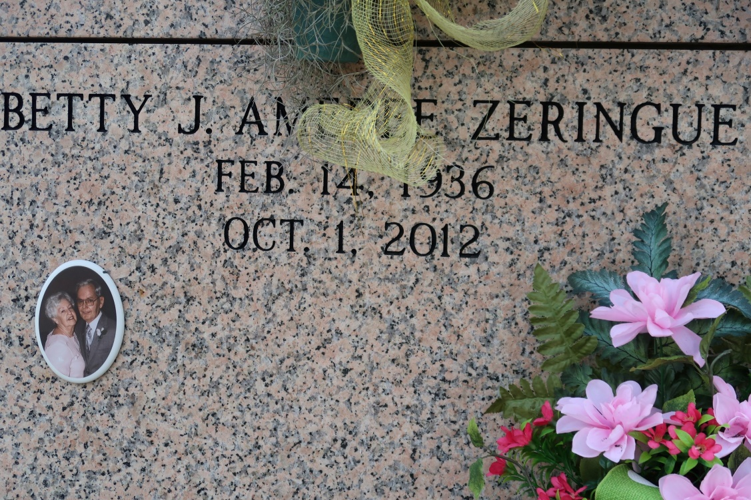

Betty Jane Amedee Zeringue, 76, a native and lifelong resident of St. James, Louisiana, passed away peacefully Monday, October 1, 2012. She was born February 14, 1936.

She is survived by daughter, Wanda Zeringue Morris and husband Kenny; son, Randall Zeringue and wife Jennifer; daughter, Charlene Zeringue Gravois and husband Rudy; son, Jason Zeringue; brother, Patrick Amedee; grandchildren, Bret, Dusty, Christina, Kimberly, Danielle, Leah, and Shelby; and great-grandchildren, Nathan and Kyle.

She is preceded in death by her husband, Allen Zeringue; parents, Semar and Verna Bye Amedee; brother, Manuel Amedee; and granddaughter, Cherie Morris. She was a homemaker, a member of St. James Catholic Church Choir, and a member of Christian Mothers. She possessed a talent and passion for both sewing and gardening. A devoted mother and grandmother, she will be dearly missed by all who loved and knew her. In lieu of flowers, donations can be made to the American Cancer Center Society, 10528 Kentshire Ct., Baton Rouge, LA 70810.

Thibodaux Funeral Home is in charge of arrangements

The Advocate, Baton Rouge, LA

Tuesday, October 2, 2012