Kenneth John Zeringue

December 17, 1961 – November 14, 2001

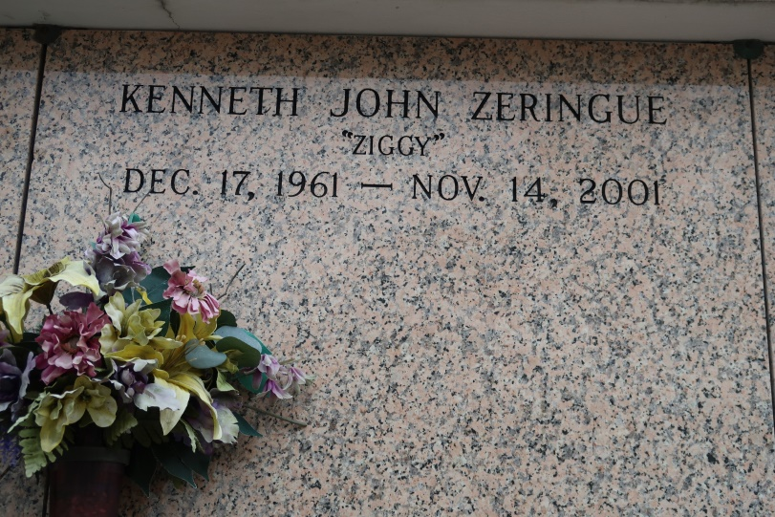

On Wednesday, November 14, 2001 At 7:45 Pm In Donaldsonville. Age 39. A Native Of St. James And A Resident Of Donaldsonville. Husband Of Victoria Hendrix Zeringue Of Donaldsonville. Son Of J. Victoria And Mary Ann Ordoyne Zeringue Of St. James. Step Father Of Tanya Williams, Tommy Williams And Johnny Hendrix. Brother Of Brian Zeringue Of Prairieville, Dennis Zeringue Of Vacherie, Anthony Zeringue Of River Ridge, Gregory And Matthew Zeringue Both Of St. James. Also Survived By 3 Grandchildren.

He Was A Member Of The St. James High School Football Championship Team Of 1979.Mass Of Christian Burial At 11 Am On Saturday At St. James Catholic Church In St. James, Conducted By Rev. Louis Oubre.. Interment In Church Mausoleum.   
 Visitation Friday At Ourso Funeral Home, Donaldsonville From 6 Pm Until 10 Pm And Saturday From 9 Am Until 11 Am At St. James Catholic Church. Arrangements By Ourso Of Donaldsonville.

Unknown source

\*\*\*\*\*

ST. JAMES - Kenneth John "Ziggy" Zeringue, 39, a native of St. James and resident of Donaldsonville, died Nov. 14. He was the husband of Victoria Hendrix Zeringue and stepfather of Tanya Williams, Tommy Williams and Johnny Hendrix. He was the son of J. Victoria and Mary Ann Ordoyne Zeringue and brother of Brian, Dennis, Anthony, Gregory and Matthew Zeringue. He is survived by three grandchildren.   
 He was a member of the St. James High School football championship team of 1979. Services are today at 11 a.m. at St. James Catholic Church, St. James, with interment at the church cemetery. Visitation   
starts at 9 a.m.

L'Observateur (LaPlace, LA)

Monday, November 19, 2001  
Contributed by Jane Edson