Charles Alexander
December 8, 1878 – December 4, 1956

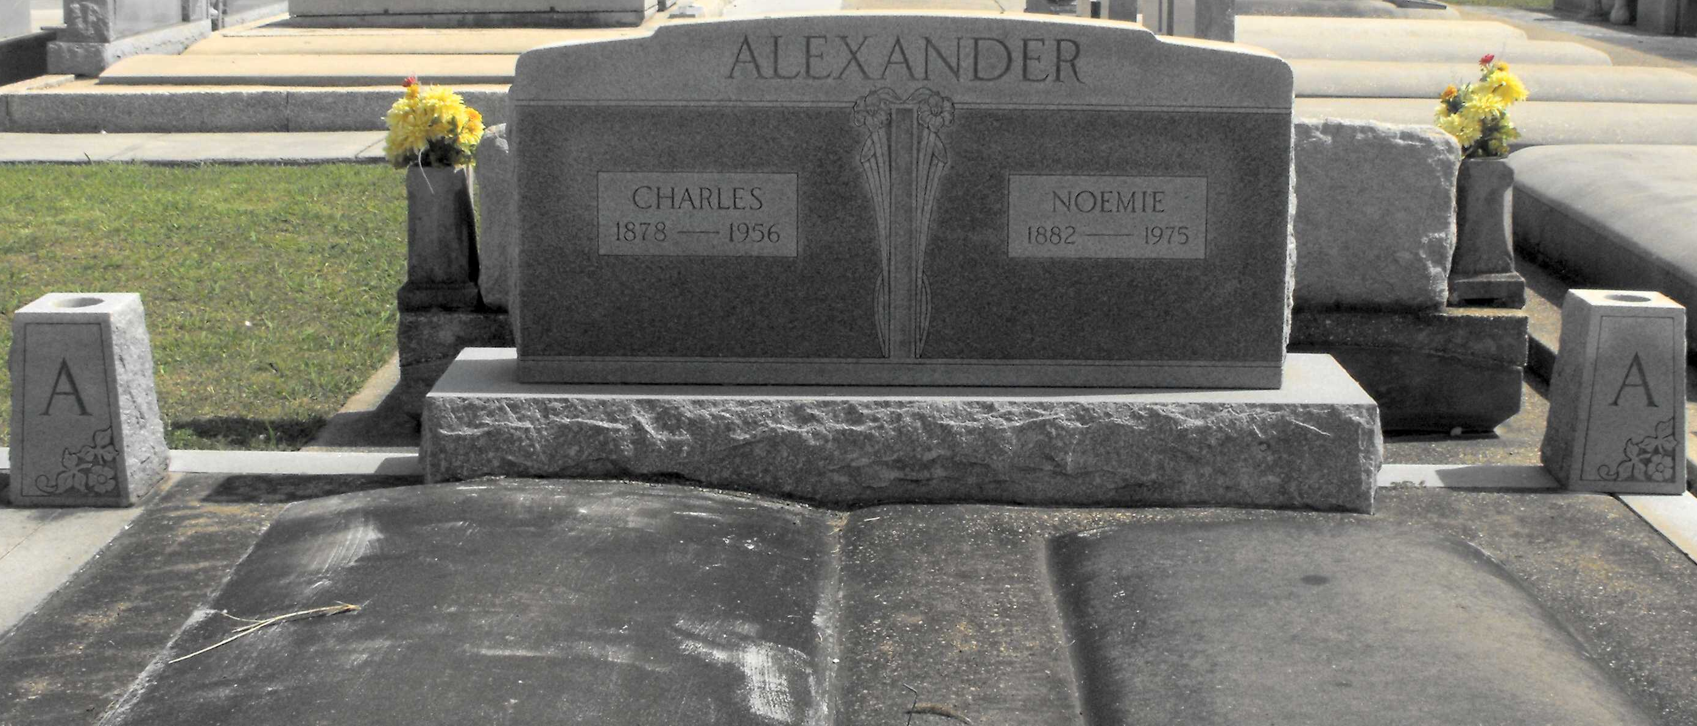
Photo by Mary Agnes Hammett

ALEXANDER – At Hotel Dieu, New Orleans, La., on Tuesday, December 4, 1956, at 10:50 o’clock a.m.. Charles Alexander, beloved husband of Noemie Breaud; father of Otis B. Sr. of New Orleans, La., Dr. Lee J. of Dallas, Tex., H. C. Alexander Sr. of Lutcher, La., and the late Lloyd M. Alexander Sr. of Hahnville, La.; brother of Mrs. Ida Gibson, Mrs. Clair Dupuy, Mrs. Adele Giebon, Mrs. Elvire Clement, Amedee Alexander, all of New Orleans, La., Mrs. Odette Millet of Garyville, La., and of the late Jerry Alexander; aged 78 years; a native of Garyville, La., and a resident of Lutcher for 50 years. Relatives and friends of the family, also officers and member of the Louisiana State Funeral Directors Association, are invited to attend the funeral, which will take place from the Alexander Funeral Home, Lutcher, La., on Thursday, December 6, 1956, at 10 o’clock a.m. Religious services at St. Joseph church, Paulina, La. Interment in St. Joseph cemetery, Paulina, La.

The Times-Picayune, New Orleans, Louisiana
Thursday, December 6, 1956, p. 2

