Noemie (Breaud) Alexander
1882 – May 9, 1975

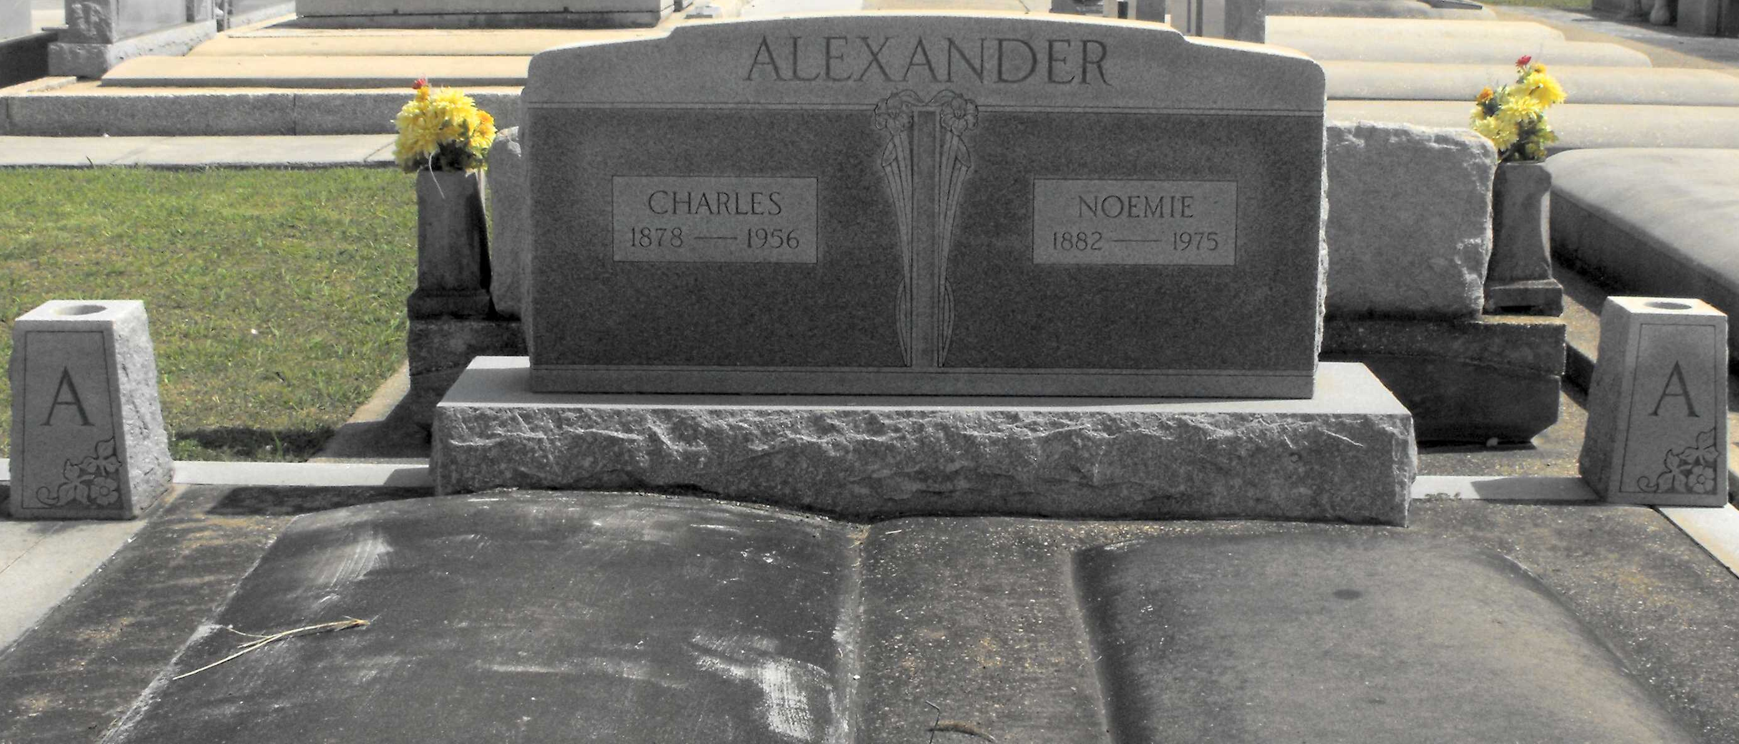
Photo by Mary Agnes Hammett

ALEXANDER, MRS NOEMIE BREAUD – Died at 7:10 p.m. Friday, May 9, 1975, at her residence in Lutcher. She was 92, a native of Vacherie. Body at Alexander Funeral Home, Lutcher, with visiting from 6 to 10 p.m. Sunday and from 8 to 9:45 a.m. Monday. Religious services at St. Joseph Catholic Church, Paulina, at 10 a.m. Monday. Burial in the church cemetery. Survived by two sons, Dr. Lee J. Alexander, Dallas, Tex., and Hayward C. Alexander Sr., Lutcher; 14 grandchildren and 34 great-grandchildren. Preceded in death by her husband, Charles Alexander; two sons, Lloyd M. Alexander Sr. and Otis B. Alexander Sr.; two brothers, Clarence and Albert Breaud; and a sister, Mrs. Emile Graugnard. She was the wife of the founder of the Alexander Funeral Home, Lutcher

Morning Advocate, Baton Rouge, Louisiana
Saturday, May 10, 1975, p. 6-A

