Rhonda (Alexander) Heald
May 14, 1952 – May 5, 2014

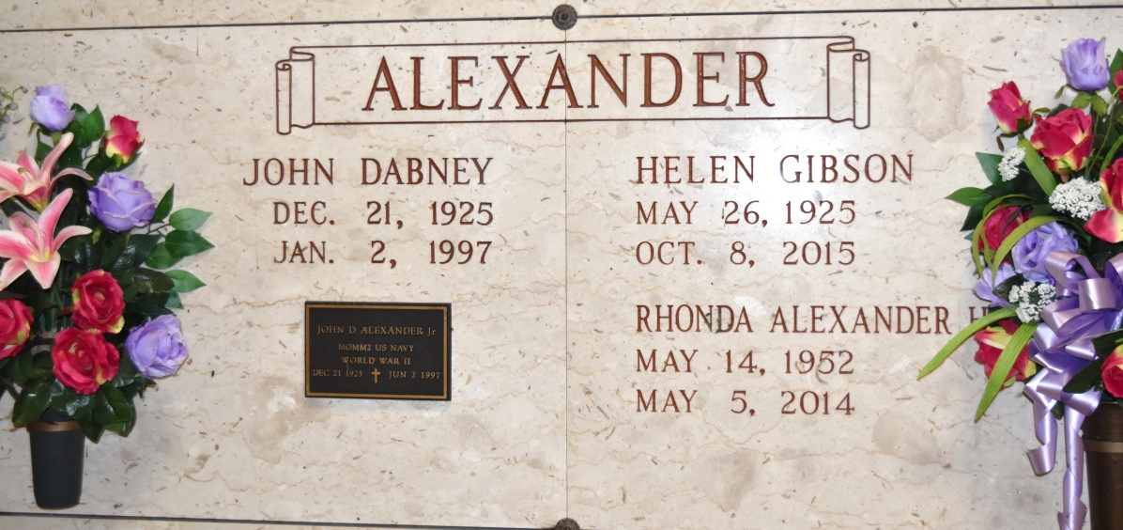

Rhonda Alexander Heald, born May 14, 1952 in Plaquemine, LA, raised in Gramercy, LA, and a long time resident of Beaumont, TX, passed away on May 5, 2014. She was a 1970 graduate of Lutcher High School and a graduate of Louisiana State University, where she was a member of the LSU Golden Girls.
Rhonda was preceded in death by her father, John "J.D." Alexander. Survived by her mother, Helen Alexander of Gramercy; son Nick Heald and wife Brandi and granddaughters, Hannah and Alexandra Heald of Columbus, Ohio; son Jeffrey Heald of Columbus, Ohio; brother Mark Alexander and wife Jane of Baton Rouge; and niece and godchild Katy Alexander Bordelon and husband Matt of Baton Rouge.
Visitation will be Saturday, May 17, from 10 AM until the Mass of Christian Burial at 11 AM at Sacred Heart Catholic Church in Gramercy. Entombment will follow in St. Joseph Cemetery in Paulina, LA.

Advocate, The (Baton Rouge, LA)
Monday, May 12, 2014

