Mary (Dottolo) Arceneaux
August 15, 1933 – June 15, 2021

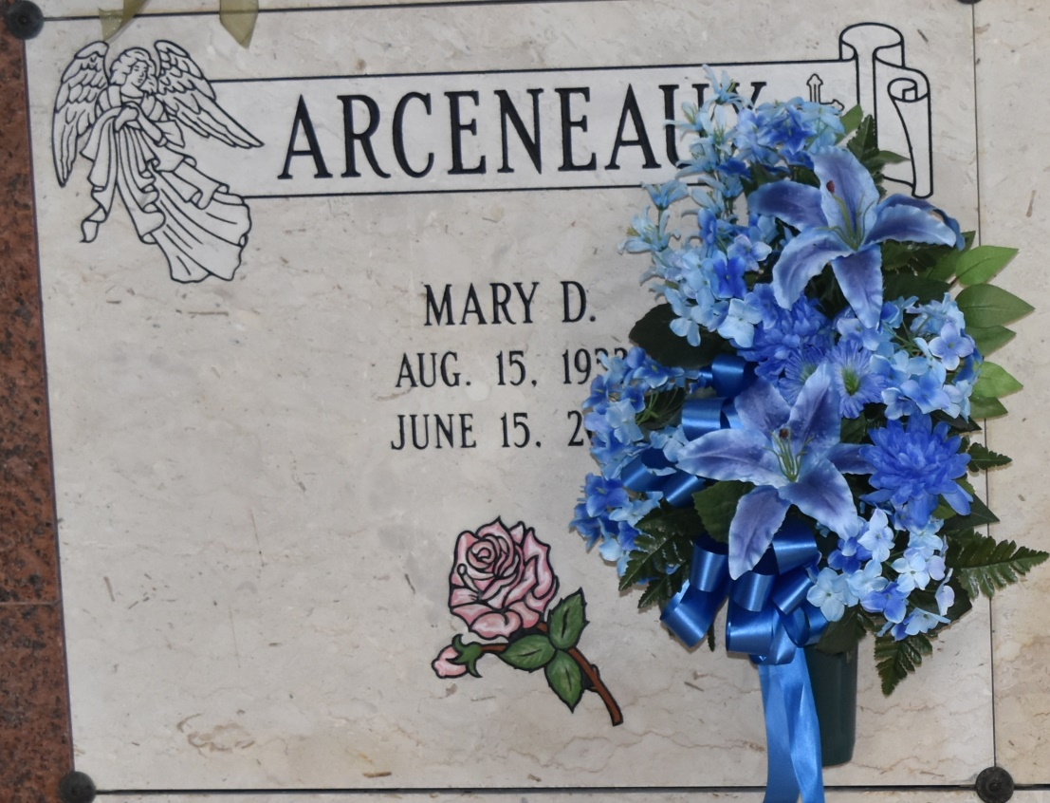

Mary Dottolo Arceneaux was born on August 15, 1933 and passed away on June 15, 2021 and is under the care of H.C. Alexander Funeral Home.
Visitation will be held on June 21, 2021 at 10:30 am at Sacred Heart of Jesus Catholic Church, 616 E Main St., Gramercy, LA. Funeral Mass will be held on June 21, 2021 at 12:00 pm at Sacred Heart of Jesus Catholic Church, 616 E Main St., Gramercy, LA. Interment will be held on June 21, 2021 at Saint Joseph Cemetery, Paulina, LA.
H. C. Alexander Funeral Home, Norco, Louisiana

