Michael Henry Babin
August 4, 1942 – May 4, 1947

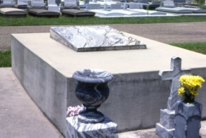

Photos by Dwayne Montz

Louisiana, U.S., Statewide Death Index, 1819-1964

Name: Micheal H Babin
Gender: Male
Race: White or Mexican (White)
Age: 4
Birth Year: 1943
Death Date: 4 May 1947
Death Place: St. Charles, Louisiana, USA
Volume: 6

