Luella Pearl (Lamb) Becnel
August 18, 1918 – October 30, 2006

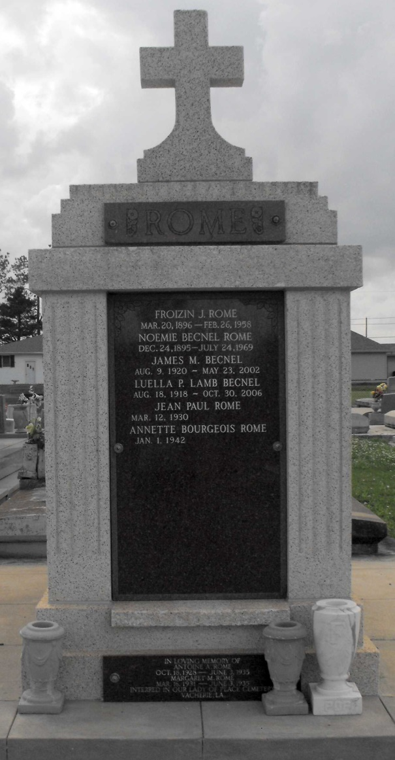
Photo by Mary Agnes Hammett

Ellabell - Luella Pearl Lamb Becnel, 88, of Ellabell, Georgia, widow of James Moffet Becnel, died Monday morning, October 30, 2006, at the home of her son under the care of Hospice Savannah. Funeral plans are incomplete and will be announced by Gamble Funeral Service, 410 Stephenson Avenue. Savannah.

Morning News, Savannah, Georgia
October 31, 2006

