Adam Paul Berthelot
January 26, 1878 – February 18, 1950

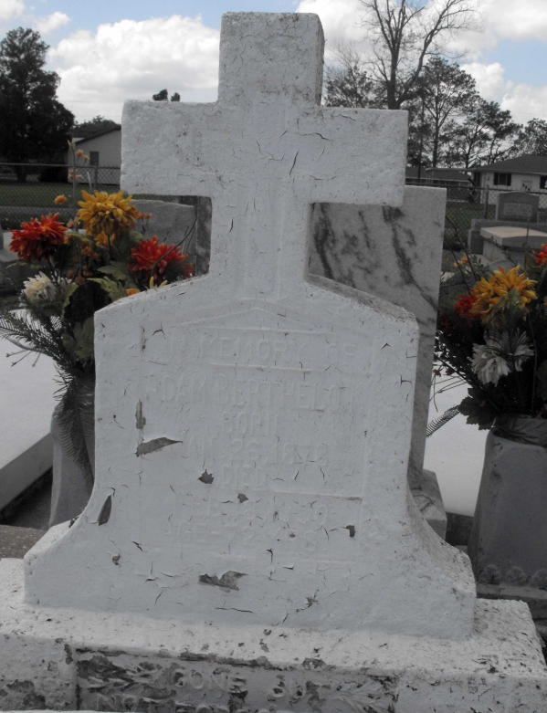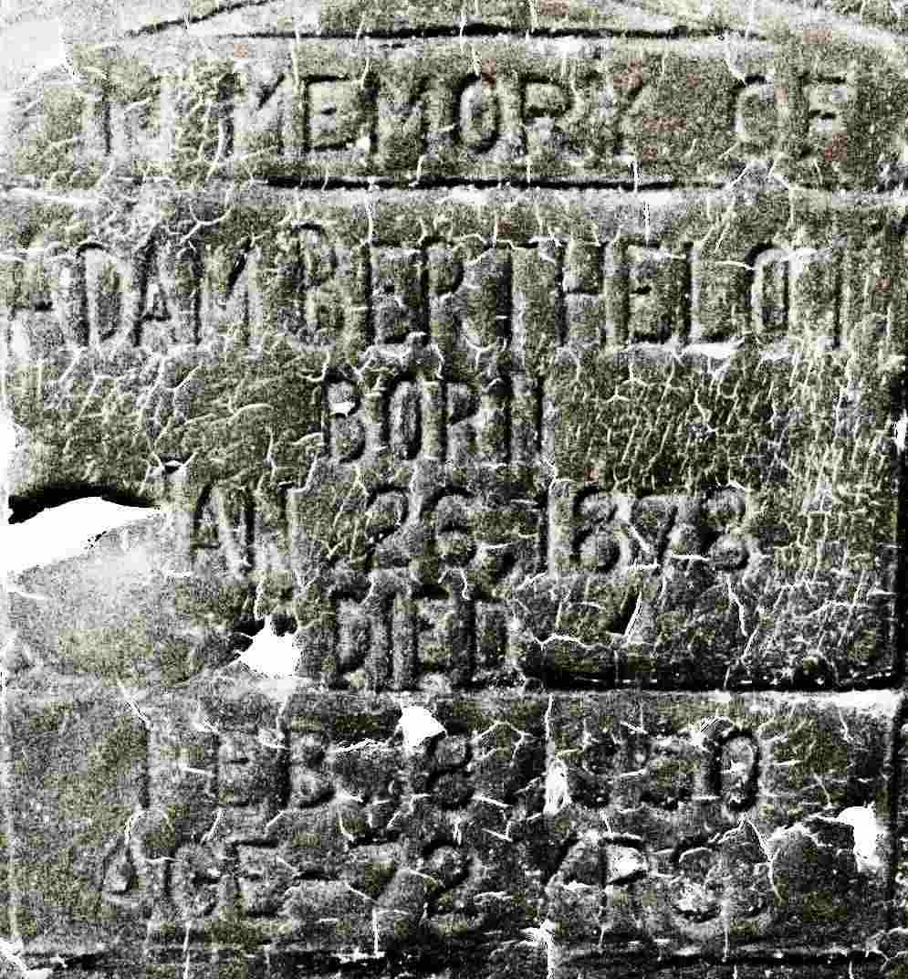
Photos by Mary Agnes Hammett

Information from death certificate
Spouse Blanche Poche
Father Romain Berthelot
Mother Leocadie LeBeau
Cause of death Cerebral Hemorrhage/Arteriosclerotic hypertension

Contributed by Mary Agnes Hammett

