Anicet J. Berthelot
August 17, 1915 – January 22, 1985

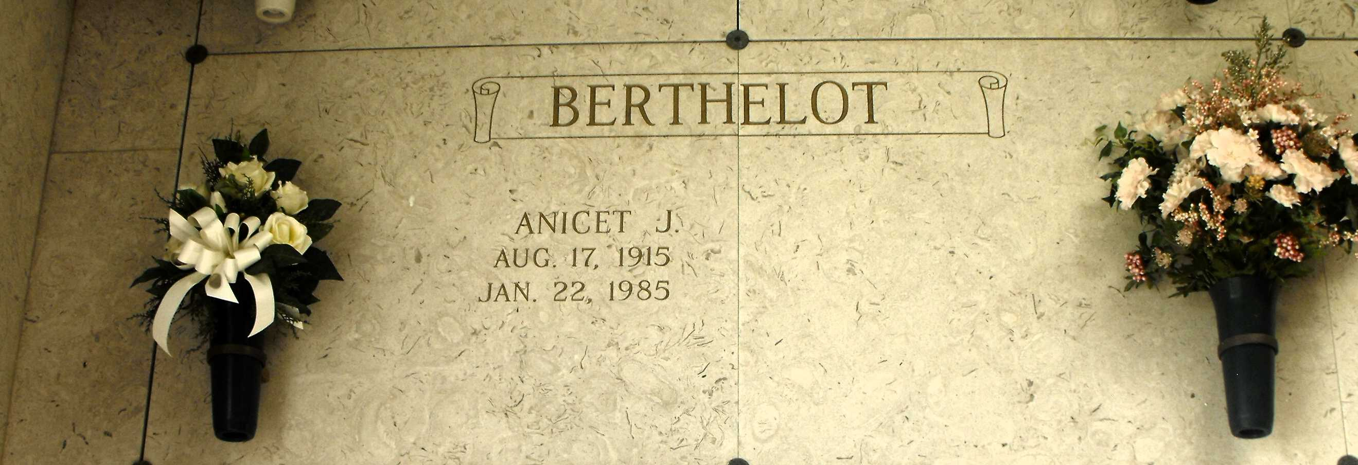
Photos by Mary Agnes Hammett

Anicet J. Berthelot (Termite) on Tuesday, January 22, 1985 at 8:30 o’clock a.m., beloved husband of Enola Richard Berthelot, father of Ronald Berthelot of Pensacola, FL, Donald Berthelot of Gramercy, La., Tommy Berthelot of Laplace, La., and Laura Vicknair of Destrehan, La., brother of Dalton and Alvin Berthelot, Margie Ory, Mildred Louque, Blanche Baham, and the late Roger and Felicie Berthelot, son of the late Fortune and Blanche Berthelot, also survived by 9 grandchildren, age 69. A native of Paulina, La., and a resident of Norco for the past 35 years.
Relatives and friends of the family, also officers and members of Shell Oil Company, St. Charles Sr. Citizens Center and The Marsh Duck Club are invited to attend the funeral services from the H.C. Alexander Funeral Home, 821 Fourth Street, Norco, La., on Thursday, January 24, 1985 at 10 o’clock a.m. Mass of Christian Burial Sacred Heart of Jesus Catholic Church, Norco, La. Entombment St. Joseph Mausoleum, Paulina, La. Friends may call on Wednesday, January 23, 1985, from 6 p.m. until 10 p.m. and from 8 a.m. until service time on Thursday. In lieu of flowers Masses preferred.

Times-Picayune, New Orleans, Louisiana
January 23, 1985

