Antoine Eloi Berthelot
December 1, 1909 – June 26, 1978

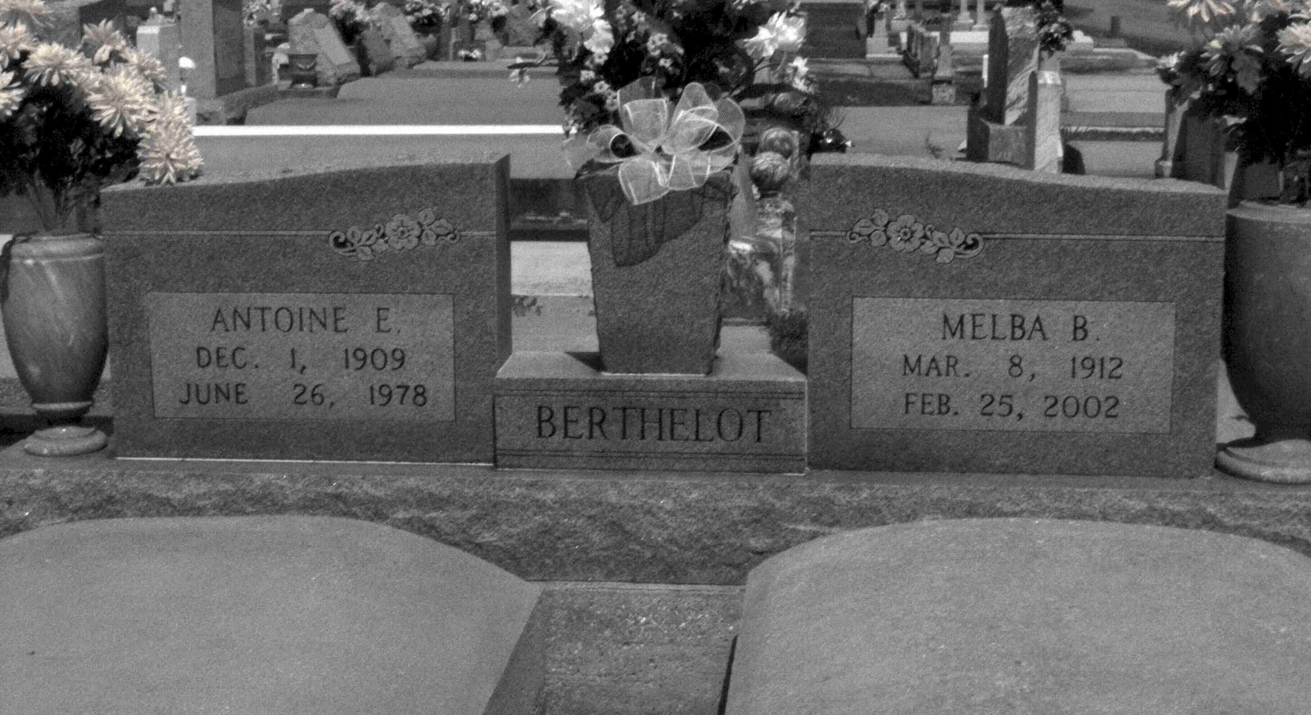
Photo by Mary Agnes Hammett

Antoine Eloi Berthelot, Sr., on Monday, June 26, 1978, at Hotel Dieu Hospital, New Orleans, at 3:45 o’clock p.m.; husband of Melba Josephine Bourgeois Berthelot; father of Mrs. Robert (Melba) LeBlanc, Mrs. Albert (Marietta) Bourgeois, Mrs. Godfrey (Joyce) Millet, Mrs. Sharon Bourgeois, Mrs. Ronald (Denny) Melancon and Antoine E. Berthelot, Jr.; brother of Mrs. Wester Perret, Sr., Mrs. Henry Bossier, Pershing Berthelot, Sr., Joseph Berthelot, Sr., and Raoul Berthelot; also survived by 19 grandchildren, a resident of Gramercy, La.; age 48 years.
Relatives and friends of the family, are invited to attend the funeral services from the Alexander Funeral Home, Lutcher, La., with religious services at the Sacred Heart Catholic Church, Gramercy, La., on Wednesday, June 28, 1978, at 10:00 o’clock a.m.
Interment in St. Joseph Cemetery, Paulina, La. Friends may call on Tuesday from 3:00 p.m. until 10:00 p.m. and on Wednesday from 8:00 a.m. until Funeral Home (sic – until services).

Times-Picayune, New Orleans, Louisiana
Tuesday, June 27, 1978, Sec. 1, p. 12

