Mrs. Fortune Berthelot
formerly Blanche Roussel
November 12, 1885 – August 28, 1932

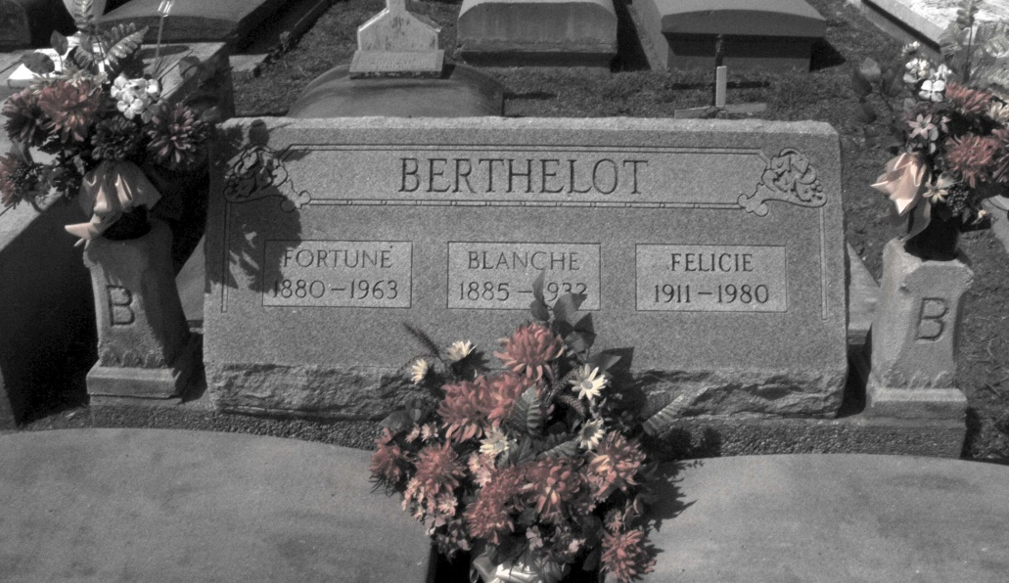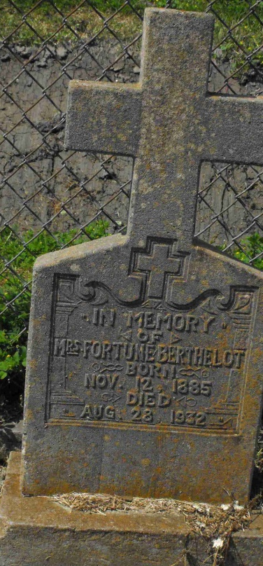
Photos by Mary Agnes Hammett

Woman, Daughter Killed in Sunday Highway Accident

New Orleans, Aug. 29 (AP) – Mrs. Fortune Berthelot, 48, of Paulina, La., died today in Charity hospital here, the second fatality from a Sunday afternoon automobile wreck on the Jefferson highway near Kenner. The other victim was Mrs. Artidore Roussel, 72, of Paulla (sic-Paulina), who was killed instantly. Mrs. Berthelot was a daughter of Mrs. Roussel. Five other persons were hurt in the accident and one of them, Maurice Messina, 8, was still in a critical condition. The car turned over on its occupants after it had left the road in some gravel on a curve. The party were en route to Charity hospital to visit a sick relative at the time of the accident.

Morning Advocate, Baton Rouge, Louisiana
Tuesday, August 30, 1932, p. 11

