Elisca (Simon) Berthelot
March 4, 1886 – December 12, 1966

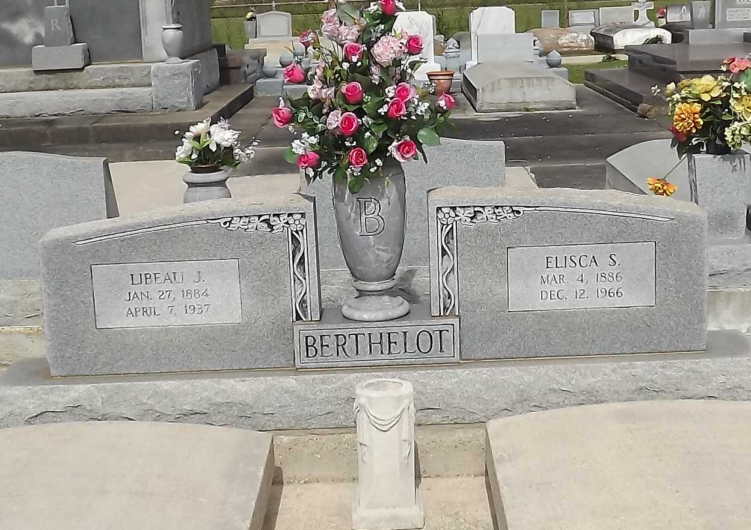
Photo by Mary Agnes Hammett

BERTHELOT, MRS. ELISCA SIMON

Died at 7:45 a.m. Monday, Dec. 12, at her residence in Gramercy. A native of Vacherie and resident of Gramercy, she was 80. Body to be at the Alexander Funeral Home in Lutcher until 9:45 a.m. Tuesday. Solemn requiem high mass will be said at 10 a.m. Tuesday at Sacred Heart Catholic Church. Interment in St. Joseph Cemetery in Paulina. She is survived by four sons, Antoinne, Raoul, Pershing and Joseph Berthelot, all of Gramercy; two daughters, Mrs. Wester Perret and Mrs. Henry Bossier, both of Gramcery; 25 grandchildren and 16 great grandchildren. She was preceded in death by her husband, Libeau Berthelot; two sisters, Mrs. Anatole Kliebert and Mrs. Jerome Bovia, and two brothers, Edme and Joseph Simon. She was a member of the Sacred Heart Church Altar Society. The family request masses be offered in lieu of flowers.

Morning Advocate, Baton Rouge, Louisiana
Tuesday, December 13, 1966, p. 12-A

