Eunice (Laiche) Berthelot
January 3, 1930 – August 5, 2019

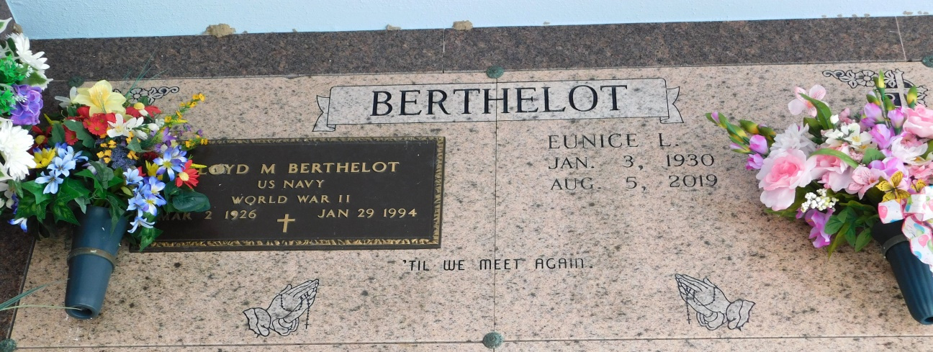
Photo by Mary Agnes Hammett

Eunice Laiche Berthelot, a native and resident of Paulina, LA passed away on August 5th, 2019 at the age of 89.
She is survived by her son, Jeffrey Berthelot (Robin), daughters, Joyce B. Lambert (Roy), Madeline Berthelot, Kim B. Scharwath (Ted) and Melissa B. Ferrier (Darren). Eunice is also survived by 11 grandchildren, 22 great-grandchildren and numerous nieces and nephews.
Eunice was preceded in death by her husband, Floyd Berthelot; parents, Collins and Josephine Laiche; brothers, Allen Laiche and Arile Laiche; sister, Theresa LeBlanc and one grandchild, Abby Berthelot.
Visitation will be on Thursday August 8th, 2019 at St. Joseph Catholic Church in Paulina, LA from 9:00am until 11:00 am. A Mass of Christian Burial will be celebrated at 11:00 am and burial will follow in the church cemetery.
The family would like to express much gratitude and thanks to the staff of Chateau St. James and Notre Dame Hospice as well as Father Vincent and Father Alec for their care, prayers and support.

Published online by Rose Lynn Funeral Home, Lutcher, Louisiana

