Geraldine (Bordelon) Berthelot
June 22, 1927 – February 1, 2010

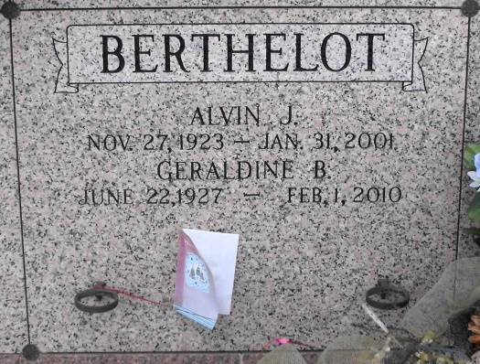
Photo by Mary Agnes Hammett

Geraldine (Gerrie/Miss B) Bordelon Berthelot passed away on Monday, February 1, 2010 at her home in Gramercy, LA surrounded by her family. Born on June 22, 1927, she was 82 years old and was a native of Eunice, LA and long time resident of Lutcher, LA. Beloved mother of daughters Diana B. Rome of Gramercy, LA and Anette B. Vial and husband Adrian G. Vial, Jr. of Luling, LA and sons Alvin J. Berthelot, Jr. and wife Linda T. Berthelot of Lutcher, LA and Andrew J. Berthelot and wife Denise C. Berthelot of Colyell, LA. Beloved grandmother of Scott and wife Karen Rome, Brandon Berthelot, Erica R. and husband John Rylee, Andrew (A.J.) Jr. and wife Jeanine Berthelot, Christy B. and husband Daine LeBlanc and Chase Berthelot. Also, granddog "Speed". Step-grandmother of Justin Vial, Alexis Vial and Mason Vial. Beloved great-grandmother of Hailee Rome, Gage Berthelot, Austin Rylee, Hunter Berthelot, Chloe Leblanc and Evan Rylee. Step-great-grandmother of Josh Stevens and Lindsay Nardi. Beloved sister of Thelma B. West and husband Col. Bill Brand, James Bordelon and wife Mary Ellen, and twins Betty and Mary Bordelon. She is also survived by sisters-in-law Rose Berthelot and Enola Berthelot, numerous cousins and special friend Delores (Dee) Berthelot.
Preceded in death by husband Alvin (Coonie) J. Berthelot, Sr., parents Avit D. and Jimmie H. Bordelon, son-in-law Charles (C.J.) Rome Jr., and infant grandson Dave Rome.
Early in her career, she was Dr. Ward Turner's assistant nurse in Lutcher. She continued her career as the administrator of Riverlands Nursing Home in Lutcher and then administrator of Twin Oaks Nursing Home in LaPlace. She retired after 20 years of service from St. James Parish Health Unit as a nutritionist in both Lutcher and Vacherie. She was a member of VFW Ladies Auxiliary Post 5852 and several other organizations.
Visitation will be on Thursday, February 4, 2010 at Rose Lynn Funeral Home from 6:00 p.m. until 9:00 p.m. Visitation will resume at Rose Lynn Funeral Home from 8:00 a.m. until 9:30 a.m. on Friday, February 5, 2010 followed by a Mass of Christian Burial at Sacred Heart Catholic Church in Gramercy at 10:00 a.m. Burial in St. Joseph Mausoleum, Paulina, LA. ROSE LYNN FUNERAL SERVICES is in charge of the arrangements. To sign and view the family guestbook, please visit www.roselynnfuneralhome.com.
Published in The Times-Picayune (New Orleans, LA) on Feb. 4, 2010.

