Leopold Paul Berthelot
March 17, 1887 – September 15, 1934

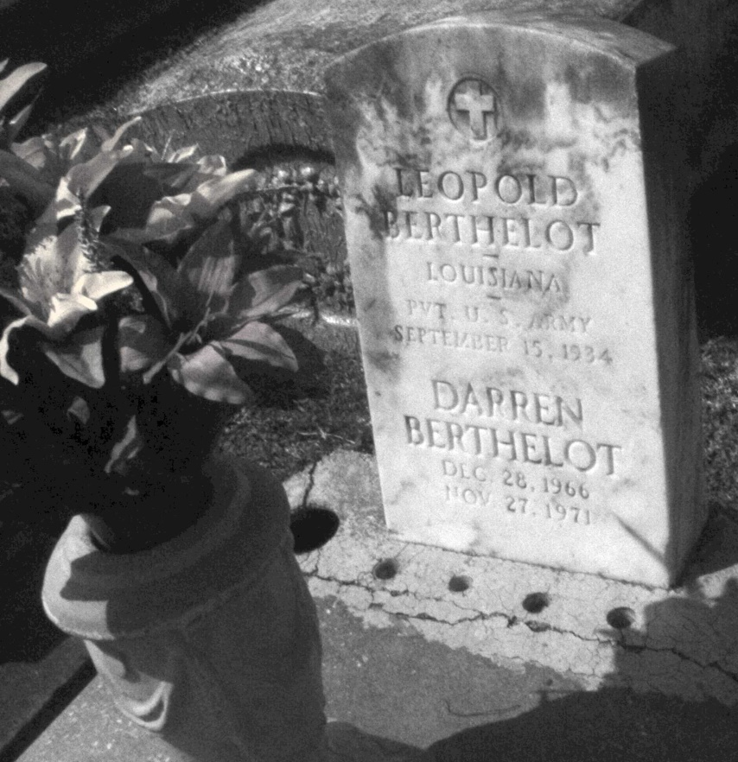
Photo by Mary Agnes Hammett

SUCCUMBS ON WAY TO LOCAL HOSPITAL
Leo Paul Berthelot Dies as Train Passes Through Kenner

While being brought to Charity hospital for treatment for an illness of eight day, Leo Paul Berthelot, 46 years old, of Gramery, La., died on an Illinois Central train as it passed through Kenner at 4:30 p.m. Sunday.
Berthelot was being brought to the city from Gramercy by his wife and two brothers-in-law, Lionel Schexnaydre and Romeo Rossell.
Mrs. Berthelot said her husband’s body would be taken to Paulina, La., for funeral service at 3 p.m. today in St. Joseph’s church of that community and interment in St. Joseph’s cemetery.

Times-Picayune, New Orleans, Louisiana
Monday, September 17, 1934, pt. 2, p. 15

