Lynn Charles Berthelot
May 29, 1925 – February 22, 1993

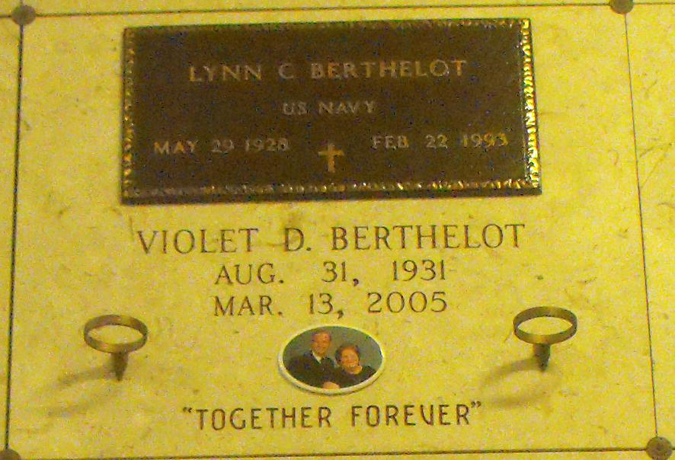
Photo by Mary Agnes Hammett

Lynn Charles Berthelot, 64 of Laplace

Died 11:30 p.m. Monday, Feb. 22, 1993, at River Parishes Hospital, LaPlace. He was 64, a native of Paulina and a longtime resident of Gramercy. He was retired from Columbia Sugar Company and was a U.S Navy veteran. Visiting at Alexander Funeral Home, 2208 Jefferson Highway, Lutcher, 6 to 10:30 p.m. Wednesday, and 8 to 9:45 a.m. Thursday. Religious services at Sacred Heart Catholic Church, Gramercy, at 10 a.m. Thursday, conducted by Father Ed Fuss. Entombment in St. Joseph Mausoleum, Paulina. Survived by wife, Violet Duhon Berthelot, Gramercy; two daughters, both of Gramercy; a son, Gonzales; a daughter-in-law, Gonzales; two sons-in-law, Gramercy, and Reserve; four sisters, Myrtle Roper, Ruth Clouatre, Enola Ory and Florence Berthelot; two brothers, Dudley and Floyd Berthelot; six grandchildren. Preceded in death by two children, Tara Villeret and Darren Berthelot; and a sister, Mary Berthelot.

Advocate, The (Baton Rouge, LA)
Wednesday, February 24, 1993

