Joseph Joachim Berthelot
May 21, 1923 – August 27, 1984

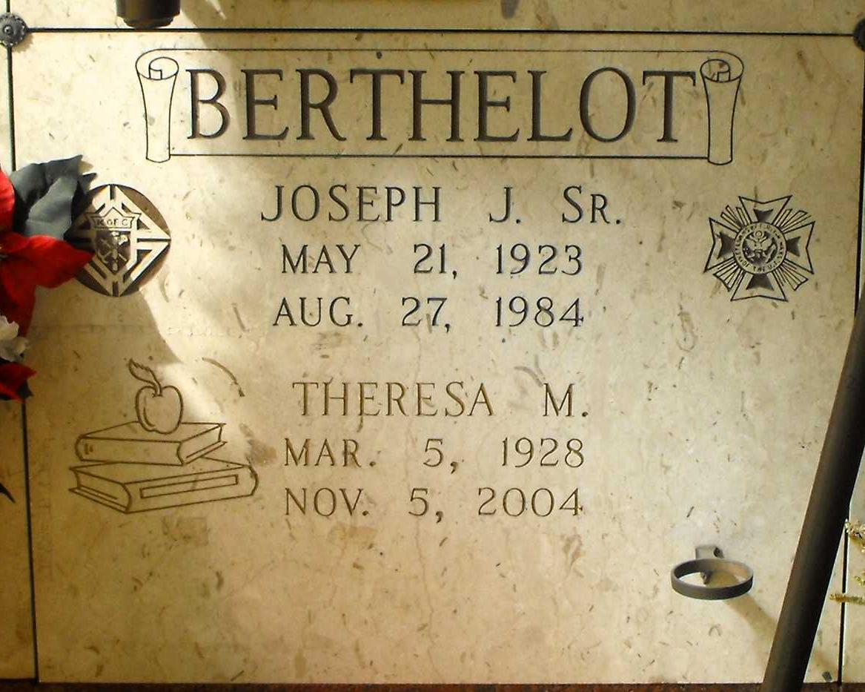
Photo by Mary Agnes Hammett

BERTHELOT, JOSEPH JOACHIUM, SR.

Died Monday, Aug. 27, 1984, at 3:45 p.m. in Lutcher. He was 61, a resident of Gramercy and native of Paulina. Visiting at Alexander Funeral Home, 107 Jefferson Hwy., Lutcher, 4 to 10 p.m. Wednesday and 8 to 9:50 a.m. Thursday. Religious services at Sacred Heart Catholic Church, Gramercy, at 10 a.m. Thursday. Entombment in church mausoleum. Survived by wife, Theresa Millet Berthelot, Gramercy; three daughters, Adele, Elisca and Theresa Berthelot, all of Gramercy; two sons, Sidney and Joseph Berthelot Jr., both of Gramercy; two sisters, Antoinette B. Perret and Gertrude B. Bossier; and a brother, Pershing Berthelot Sr. Preceded in death by parents, Libeau and Elisca Berthelot; two brothers, Antoine and Raoul Berthelot. Honorary pallbearers are employees of Colonial Sugar Company. He was a member of Arch Bishop Blenk General Assembly 4th Degree, Knights of Columbus Council 1817, Gramercy; VFW 5852. He was past president of Chanel School Board; and past alderman and mayor pro-tem of Gramercy.
Morning Advocate, Baton Rouge, Louisiana
Wednesday August 29, 1984, p. 6-B

