Melba (Bourgeois) Berthelot
March 8, 1912 – February 25, 2002

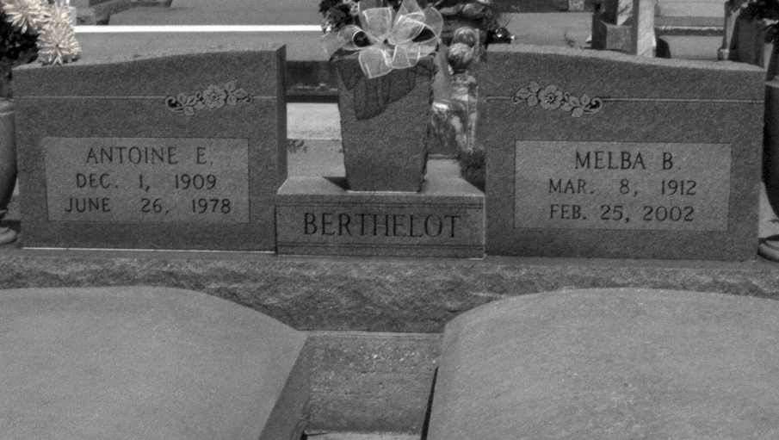
Photo by Mary Agnes Hammett

Melba (Mabel) Bourgeois Berthelot, Died on Monday, February 25, 2002 At 7:00 Am.
Wife Of The Late Antoine 'Shine' Berthelot, Sr. Daughter Of The Late Henry And Josephine Caillouet Bourgeois. Mother And Mother-In-Law Of Melba B. And The Late Robert Leblanc, Joyce B. And Godfrey Millet, Sr., Marietta B. And Albert Bourgeois, Antoine, Jr. 'Tweet' And Sandra Berthelot, Sharon B. And Malcolm Sensebe And Denny Rae B. And Ronald Melancon. Also Survived By 19 Grandchildren, 30 Great Grandchildren And 3 Step Grandchildren. Age 89.
Also Survived By 1 Sister Mildred Laurent And The Late Marguerite Laurent, Marie Doming, Mae Troxler, Edward, Randall, Raymond And Roy Bourgeois, 1 Grandchild And 1 Great Grandchild. A Native Of Convent, La. And A Resident Of Gramercy, La.
Relatives And Friends Of The Family Are Invited To Attend The Funeral Services. A Mass Of Christian Burial Will Be Celebratred On Thursday, February 28, 2002 At 11 Am At Sacred Heart Catholic Church, 1616 Main Street, Gramercy, La. Friends May Call At H.C. Alexander Funeral Home Of Lutcher, 2208 Jefferson Highway, On Wednesday Evening From 6 Until 9 Pm And At Sacred Heart Catholic Church On Thursday Morning From 8 Am Until Services. Interment Following At St. Joseph Cemetery, Paulina, La
Published in The Times-Picayune, New Orleans, Louisiana
February 27, 2002

