Paul Adams Berthelot
April 10, 1915 – April 23, 1948

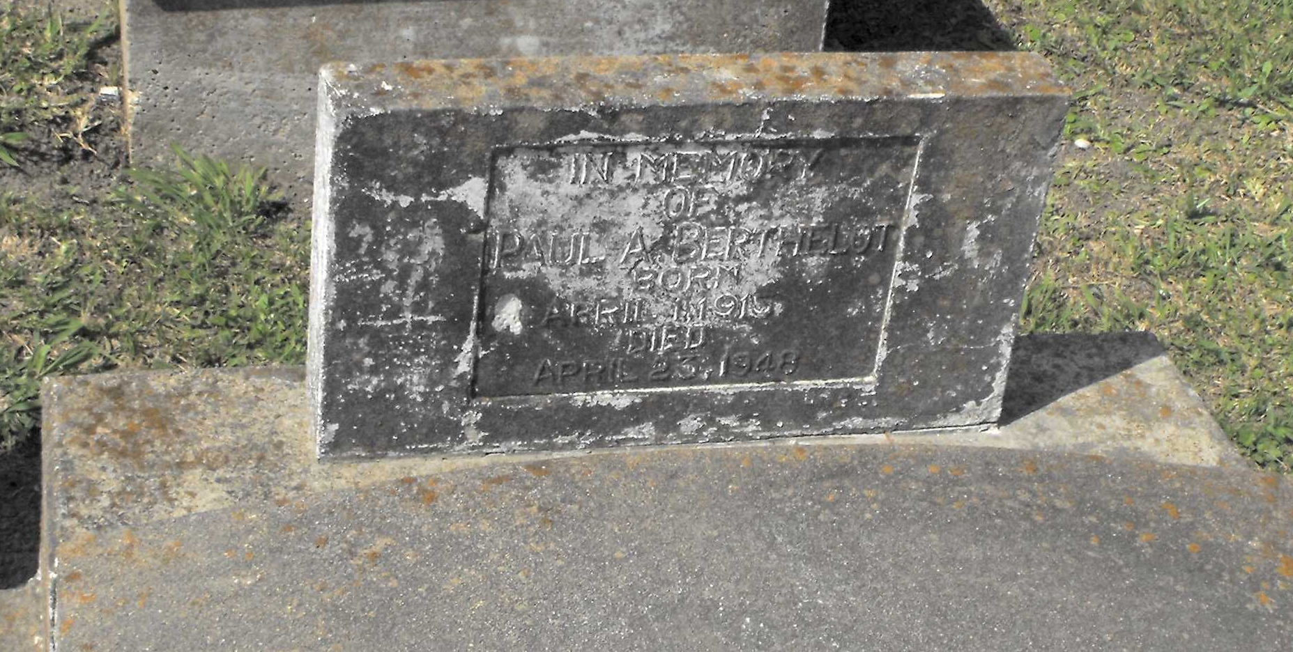
Photo by Mary Agnes Hammett

Berthelot Rites to Be at Paulina

Funeral services for Paul Adams Berthelot, 33, former New Orleanian, who was fatally injured Friday at Baytown, Tex., will be conducted today at Paulina, La.
The accident which resulted in his death occurred when he fell from a dragline in a shipyard, Berthelot, an army veteran of World War II, resided in Houston, Tex.
Survivors include three sisters residing in New Orleans, Mrs. Manuel Matrana, Mrs. John Spano and Mrs. Collins Roussel. Other survivors include his father, Adams Berthelot, Paulina, and two sisters, Mrs. Adelaide Deslattes, Houston, and Mrs. Leland Dubuc, Slidell.
The Times-Picayune, New Orleans, Louisiana
Sunday, April 25, 1948, p. 10

