Pershing J. Berthelot Sr.
December 20, 1918 – July 13, 1998

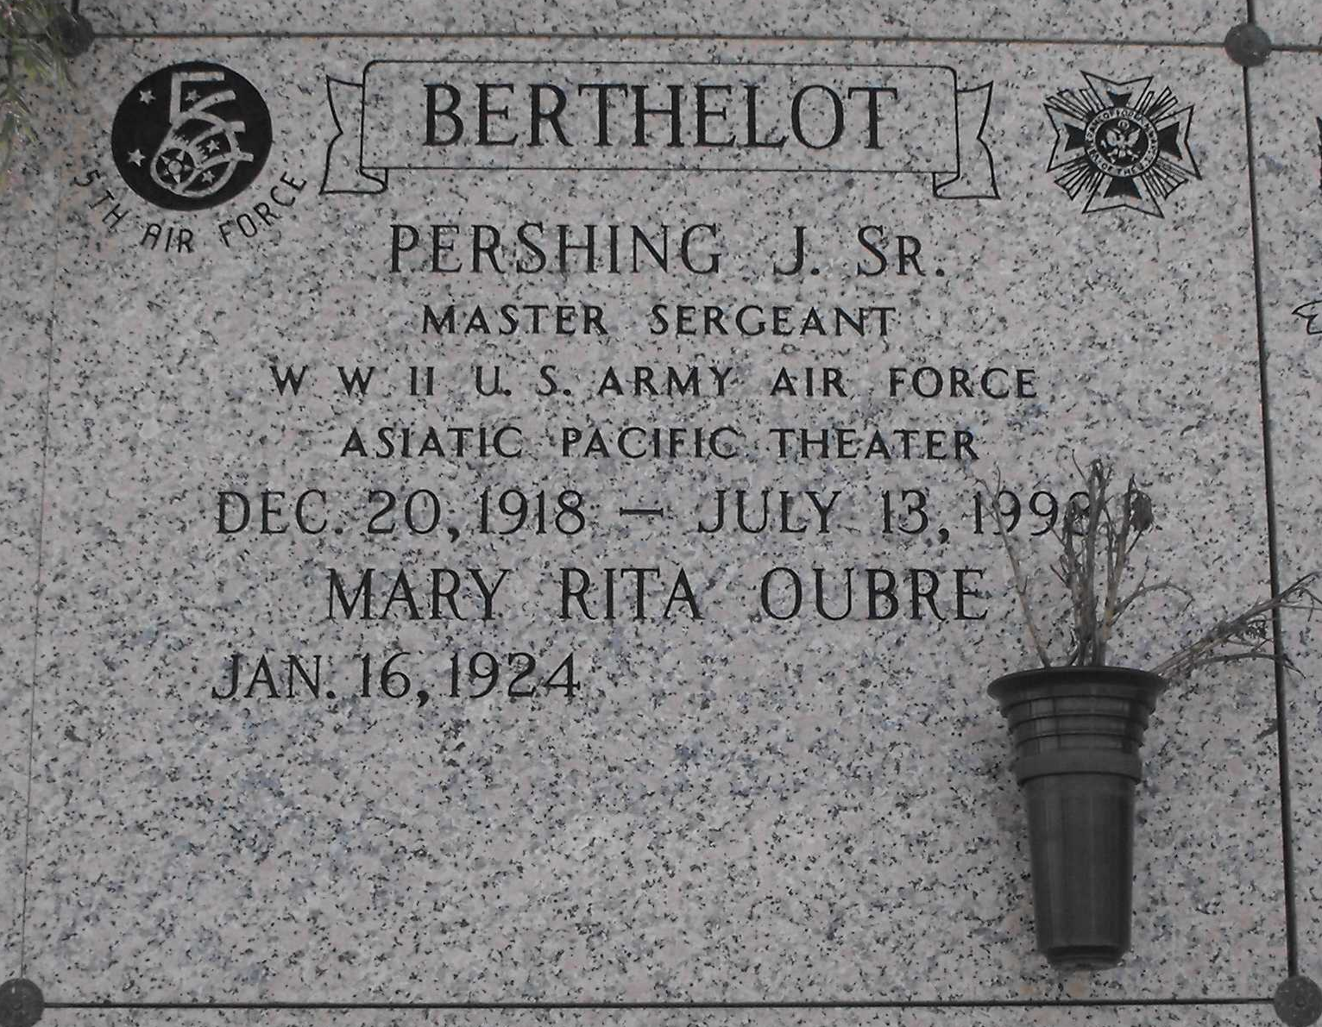
Photo by Mary Agnes Hammett

BERTHELOT SR., PERSHING J.
A retired accountant at Colonial Sugars Inc. and a resident of Gramercy, he died Monday, July 13, 1998. He was 79 and a native of Paulina. He was a U.S. Army veteran of World War II. Visiting was at Alexander Funeral Home, 2208 Jefferson Highway, Lutcher, 6 p.m. to 9 p.m. Tuesday. Visiting at the funeral home, 8 a.m. to 9:45 a.m. Wednesday. Mass of Christian Burial at Sacred Heart Catholic Church, Gramercy, at 10 a.m. Wednesday, conducted by the Rev. Louis Poche.
Entombment in St. Joseph Mausoleum, Paulina. Survived by wife, Mary Rita Oubre Berthelot, Convent; a daughter and son-in-law, Convent; three sons and daughters-in-law, and 13 grandchildren. Preceded in death by three brothers, Antoine, Raoul and Joseph Berthelot; and two sisters, Antoinette Perret and Gertrude Bossier.
Advocate, The (Baton Rouge, LA)
Wednesday, July 15, 1998

